

|  |
| --- |
| **DEPARTMENT OF COMPUTER SCIENCE AND**  **ENGINEERING** |
| Lab Manual |
| Course: Data Science Lab |
| SEM-VII |
| **A.Y. 2023-2024** |

Vision

To evolve as a Centre of excellence in Computer Science and Engineering to produce skilled and proficient global professionals to build the society.

Mission

* To provide the conducive environment for establishing students in the global platform of research and innovation.
* To educate students on cutting edge technologies with problem solving capabilities, leadership and teamwork skills.
* To inculcate the professional values with lifelong learning through curricular and co-curricular activities and create globally-aware disciplined citizens.
* To commence various initiatives for motivating students to work for the betterment of society.

Program Outcomes

**Engineering Graduates will be able to:**

1. **Engineering knowledge**: Apply the knowledge of mathematics, science, engineering fundamentals, and an engineering specialization to the solution of complex engineering problems.
2. **Problem analysis**: Identify, formulate, review research literature, and analyze complex engineering problems reaching substantiated conclusions using first principles of mathematics, natural sciences, and engineering sciences.
3. **Design/development of solutions**: Design solutions for complex engineering problems and design system components or processes that meet the specified needs with appropriate consideration for the public health and safety, and the cultural, societal, and environmental considerations.
4. **Conduct investigations of complex problems**: Use research-based knowledge and research methods including design of experiments, analysis and interpretation of data, and synthesis of the information to provide valid conclusions.
5. **Modern tool usage**: Create, select, and apply appropriate techniques, resources, and modern engineering and IT tools including prediction and modeling to complex engineering activities with an understanding of the limitations.
6. **The engineer and society**: Apply reasoning informed by the contextual knowledge to assess societal, health, safety, legal and cultural issues and the consequent responsibilities relevant to the professional engineering practice.
7. **Environment and sustainability**: Understand the impact of the professional engineering solutions in societal and environmental contexts, and demonstrate the knowledge of, and need for sustainable development.
8. **Ethics**: Apply ethical principles and commit to professional ethics and responsibilities and norms of the engineering practice.
9. **Individual and team work**: Function effectively as an individual, and as a member or leader in diverse teams, and in multidisciplinary settings.
10. **Communication**: Communicate effectively on complex engineering activities with the engineering community and with society at large, such as, being able to comprehend and write effective reports and design documentation, make effective presentations, and give and receive clear instructions.
11. **Project management and finance**: Demonstrate knowledge and understanding of the engineering and management principles and apply these to one’s own work, as a member and leader in a team, to manage projects and in multidisciplinary environments.
12. **Life-long learning**: Recognize the need for, and have the preparation and ability to engage in independent and life-long learning in the broadest context of technological change.

Course Outcome

|  |  |
| --- | --- |
| **Sr. No.** | **Course Outcomes** |
| **CO1** | Demonstrate implementation of statistical programming concepts in R. |
| **CO2** | Demonstrate the application of R package for advanced statistical analysis. |
| **CO3** | Predicting and analysing the problems involved building models to make predictions about future events or outcomes of regression techniques. |
| **CO4** | Classifying data science problems into standard typology would depend on the programming language. |

|  |  |  |  |
| --- | --- | --- | --- |
| **Sr. No.** | **List of Experiments** | **No. of Sessions** | **CO** |
| 1. | **R AS CALCULATOR APPLICATION**   1. Using with and without R objects on console 2. Using mathematical functions on console. 3. Write an R script to create R objects for calculator application and save in a specified location in disk. | 3 | CO1 |
| 2. | **DESCRIPTIVE STATISTICS IN R**   1. Write an R script to find basic descriptive statistics using summary, str, quartile function. 2. Write an R script to find subset of dataset by using subset (), aggregate () functions. | 3 | CO2 |
| 3. | **READING AND WRITING DIFFERENT TYPES OF DATASETS**   1. Reading different types of data sets (.txt, .csv) from web and disk and writing in file in specific disk location. 2. Reading Excel data sheet in R. 3. Reading XML dataset in R. | 3 | CO3 |
| 4. | **DATA VISUALIZATION**   1. Find the data distributions using box and scatter plot. 2. Find the outliers using plot.   Plot the histogram, bar chart and pie chart on sample data. | 3 | CO4 |
| 5. | **CORRELATION AND COVARIANCE**   1. Find the correlation matrix. 2. Plot the correlation plot on dataset and visualize giving an overview of relationships among data   Analysis of covariance: variance (ANOVA) if data has categorical variables | 3 | CO5 |
| 6. | **REGRESSION MODEL**  Apply logistic regression if data have a continuous independent variable. | 3 | CO5 |
| 7. | **MULTIPLE REGRESSION MODEL**  Apply multiple regressions if data has a continuous independent variable. | 3 | CO6 |
| 8. | **REGRESSION MODEL FOR PREDICTION**  Apply regression model techniques to predict data | 3 |  |

|  |  |  |  |
| --- | --- | --- | --- |
| 9. | **CLASSIFICATION MODEL**   1. Install relevant package for classification. 2. Choose classifier for classification problem. 3. Evaluation the performance of classifier. | 3 |  |
| 10. | **CLUSTERING MODEL**   1. Clustering algorithms for unsupervised classification. 2. Plot the cluster data using R visualizations. | 3 |  |

**Assignment No: -1**

**AIM:** R AS CALCULATOR APPLICATION

1. Using with and without R objects on console
2. Using mathematical functions on console
3. Write an R script, to create R objects for calculator application and save in a specified location in disk.

**Objectives: -**To create a simple R calculator application, we can use the R console for basic arithmetic operations and mathematical functions. Additionally, we can write an R script to create R objects for the calculator application and save them to a specified location on disk.

**Procedure: -** Let's go through each part step by step.

1. Using with and without R objects on the console:
   1. Open RStudio or any R environment that provides an R console. Without R objects:

You can perform basic arithmetic operations directly in the R console.

#### Output:-

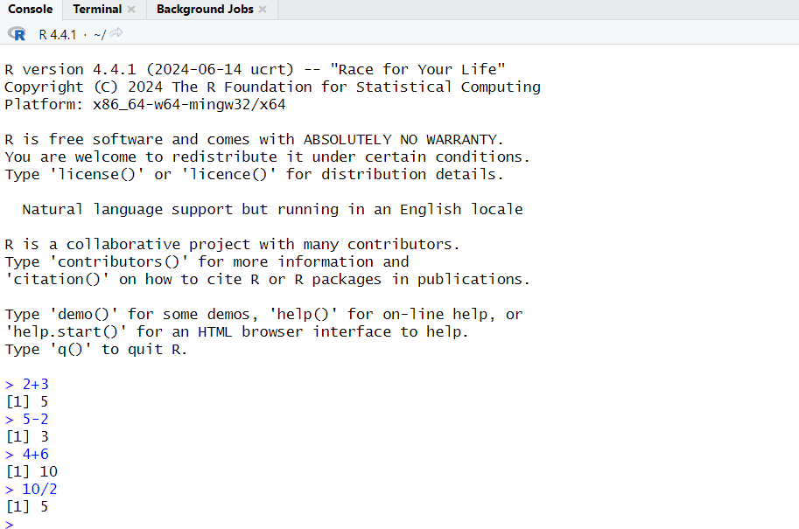

**With R objects:**

You can store values in R objects and use them in calculations.

#### Output:-

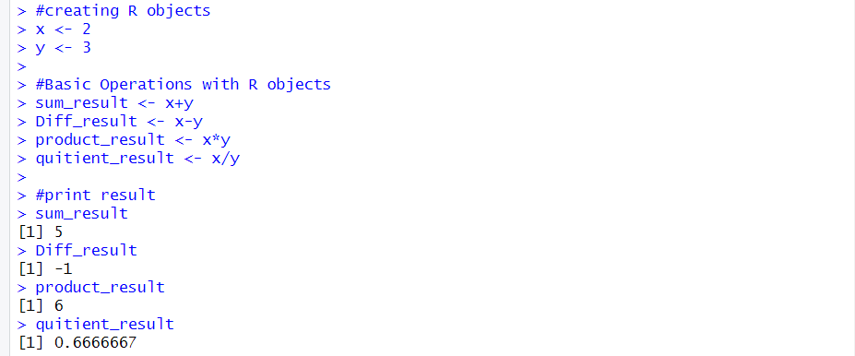

1. **Using mathematical functions on the console:**

You can use built-in mathematical functions for various calculations.

#### Output:-

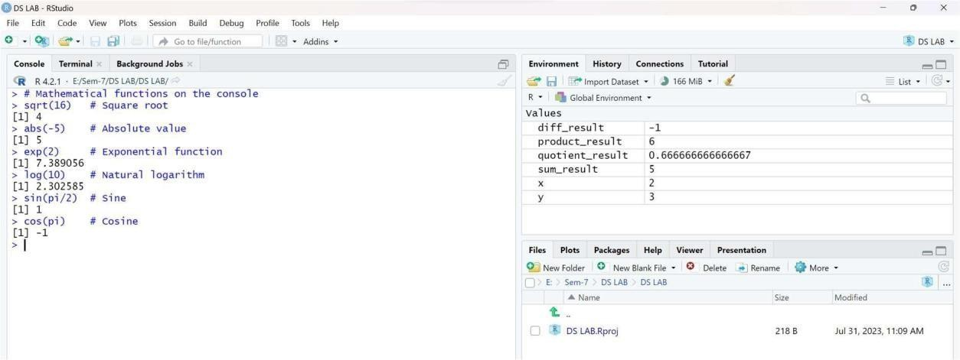

1. **Write an R script to create R objects for the calculator application and save them to a specified location on disk:**
   1. Created a new R script file ("calculator_script.R") and followed by the following code:

#### Expected Output Code:-

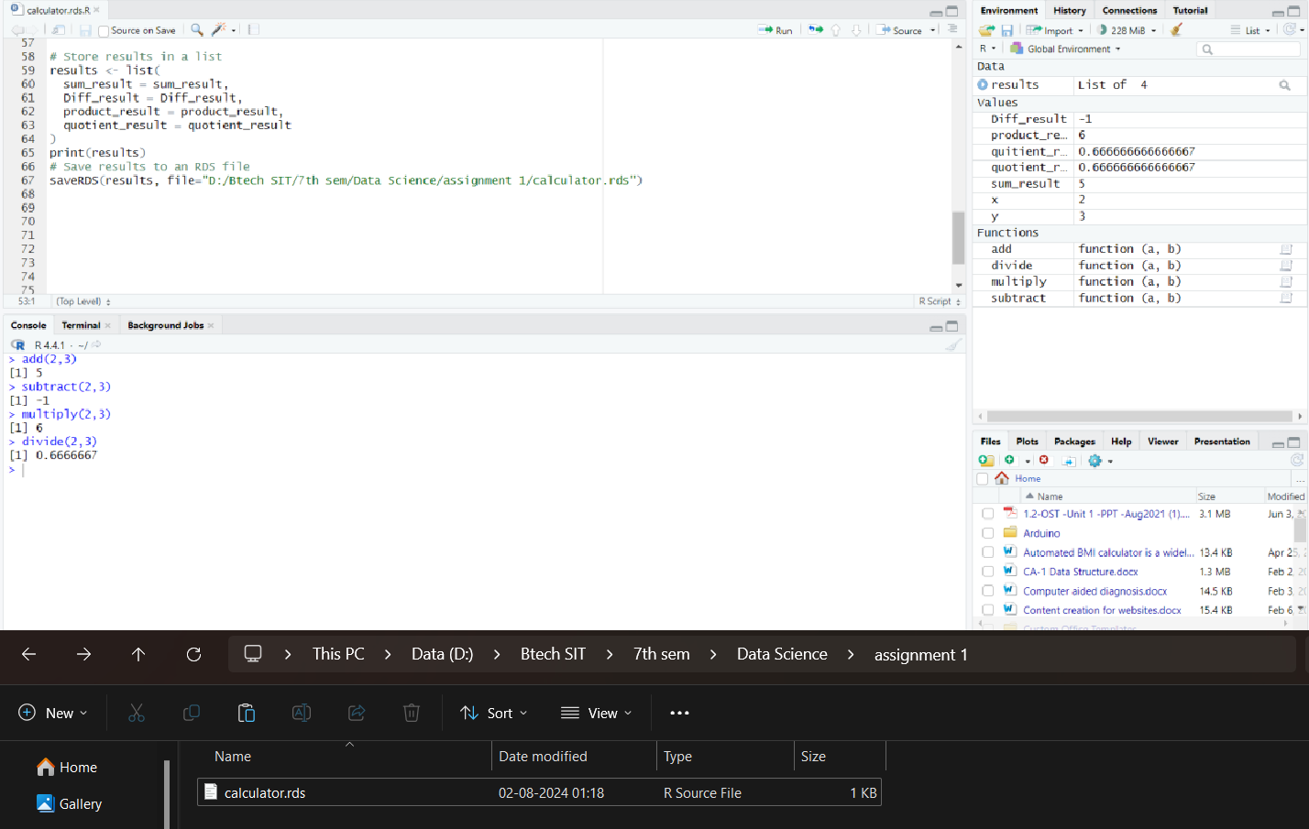

**Conclusion: -** Thus we have studied use of console with and without R objects by using mathematical functions wrote script program for calculator application using R- programming and learn how to save in a specified location in disk.

Name: -Madhur Mahajan PRN:- 22070122508

**DS LAB-2**

**AIM:** a. Write an R script to find basic descriptive statistics using summary, str, quartile ,

Mean, Median, Mode function on mtcars & cars datasets

b. Write an R script to find subset of dataset by using subset (), aggregate () functions on iris dataset.

**Objectives: -**To understand the principle of statistic and probability used for datasets.

* + 1. **Algorithm: Descriptive Statistics and Quartiles for Datasets**

1. Load necessary libraries:
2. Load the mtcars dataset:
3. Display basic descriptive statistics for mtcars dataset:
4. Display the structure of mtcars dataset:
5. Calculate quartiles for selected variables in mtcars dataset:
6. Load the cars dataset:
7. Display basic descriptive statistics for cars dataset:
8. Display the structure of cars dataset:
9. Calculate quartiles for the speed variable in cars dataset: End of Algorithm

**Sample Output:**

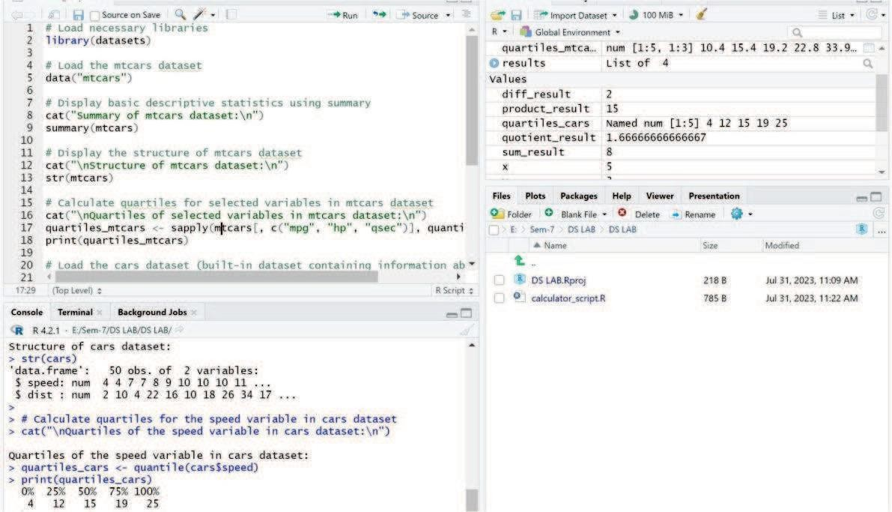

* + 1. **Algorithm: Exploratory Data Analysis on Iris Dataset**
  1. Load necessary libraries:
  2. Load the iris dataset:
  3. Display the first few rows of the iris dataset:
  4. Using subset() to find a subset of the dataset based on a condition:
  5. Display the selected subset of the iris dataset:
  6. Using aggregate() to find the mean of Sepal.Length for each species in the iris dataset:
  7. Aggregate the data based on the Species column:
  8. Display the aggregated results:
  9. End of Algorithm

**Sample Output:**

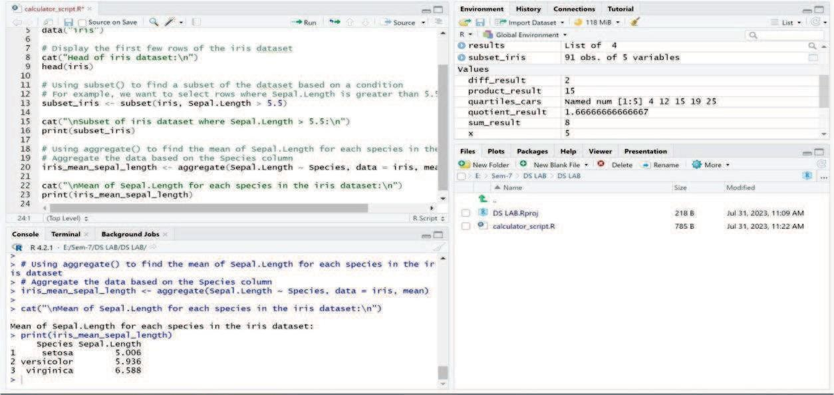

**Conclusion: -**

In the first part of the script (1), we load the mtcars and cars datasets and use the summary, str, and quantile functions to obtain descriptive statistics like summary statistics and quartiles.

In the second part of the script (2), we load the iris dataset and demonstrate how to create subsets based on specific conditions using the subset() function. Additionally, we use the aggregate() function to calculate the mean of the sepal.length variable for each species in the iris dataset.

**Assignment 3**

**EXPLORING DATA HANDLING IN R: READING AND WRITING DIVERSE DATASET FORMATS**

**a. Select and download of Two datasets from different domains**

1. **cricket_score.csv**
2. **CryptoCurrency.csv**
3. **Reading different types of data sets (.txt, .csv) from web and disk and writing in file in specific disk location.**

**CryptoCurrency Data Set**

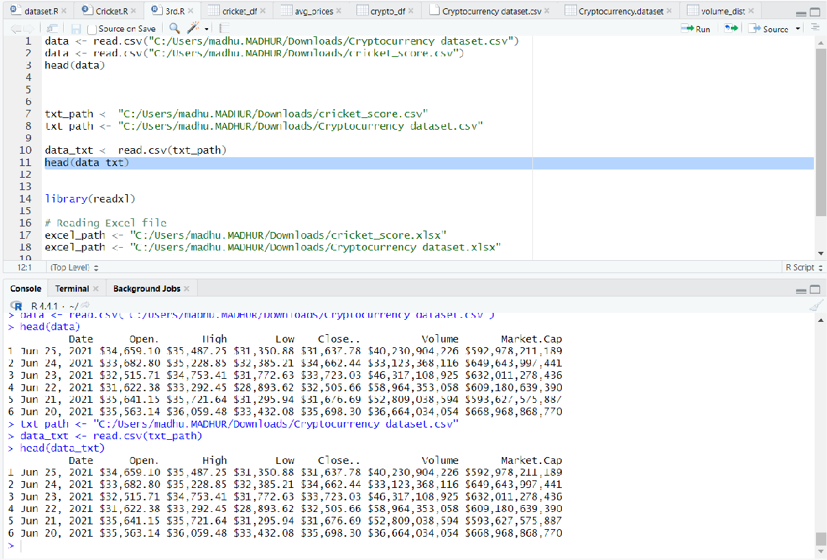

**Cricket Data Set**

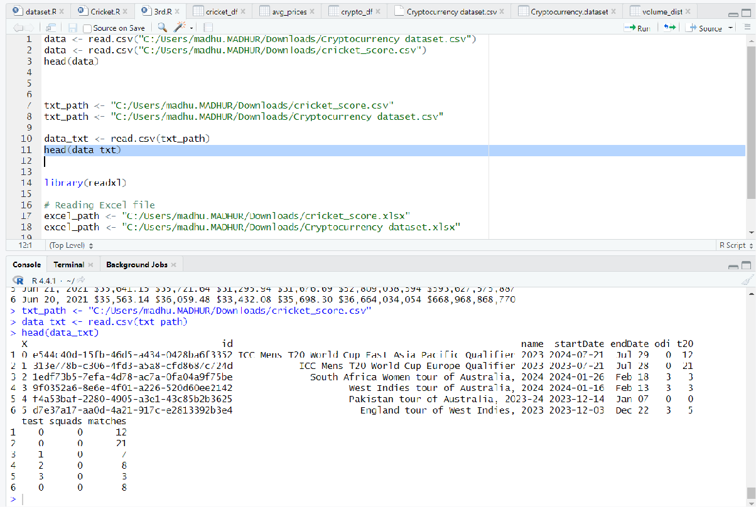

1. **Reading Excel and XML data sheet in R. CryptoCurrency Data Set**

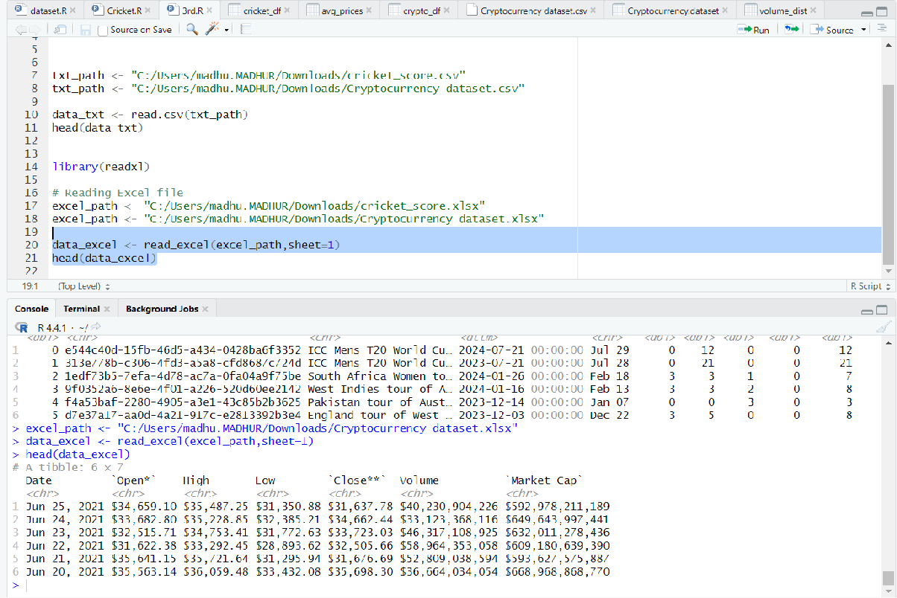

**Cricket Data Set**

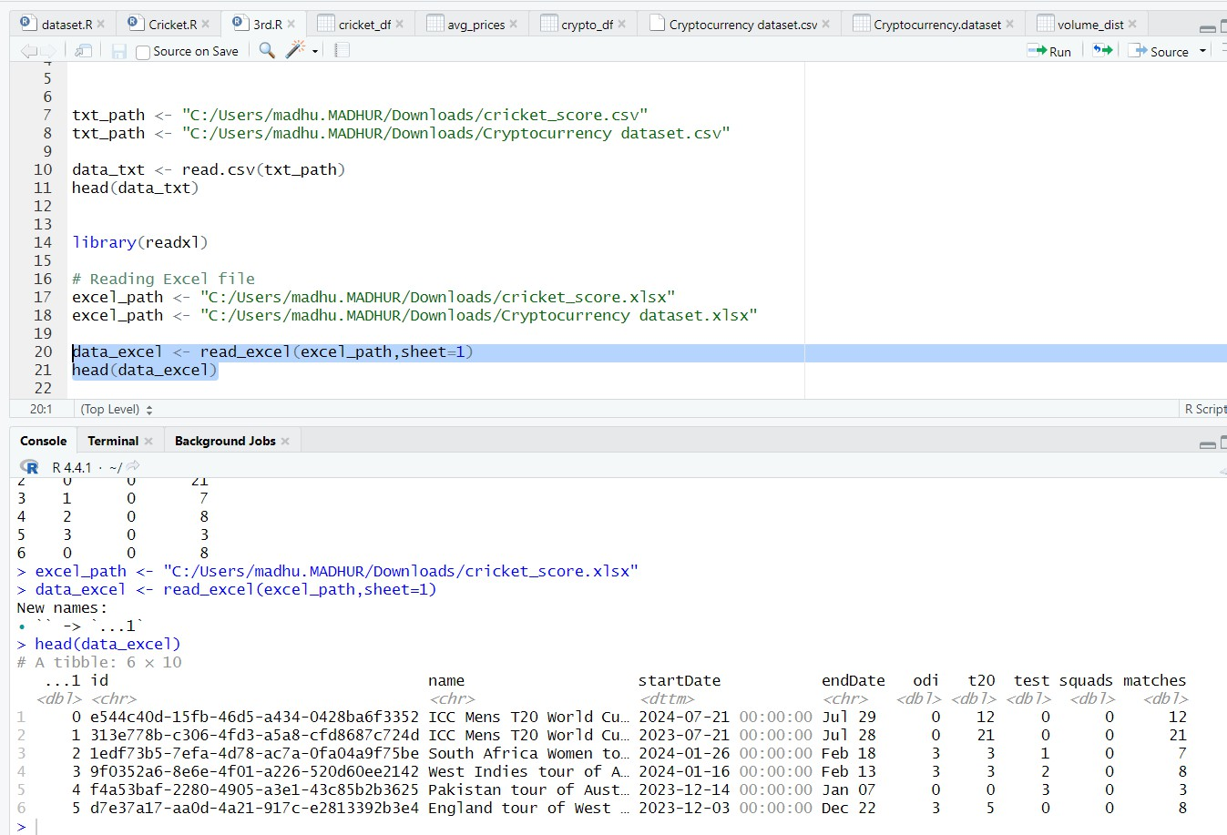

Assignment 4

1. Find the data distributions using box and scatter plot.
2. Find the outliers using plot.

c. Plot the histogram, bar chart and pie chart on sample data

Dataset: CryptoCurrency a.

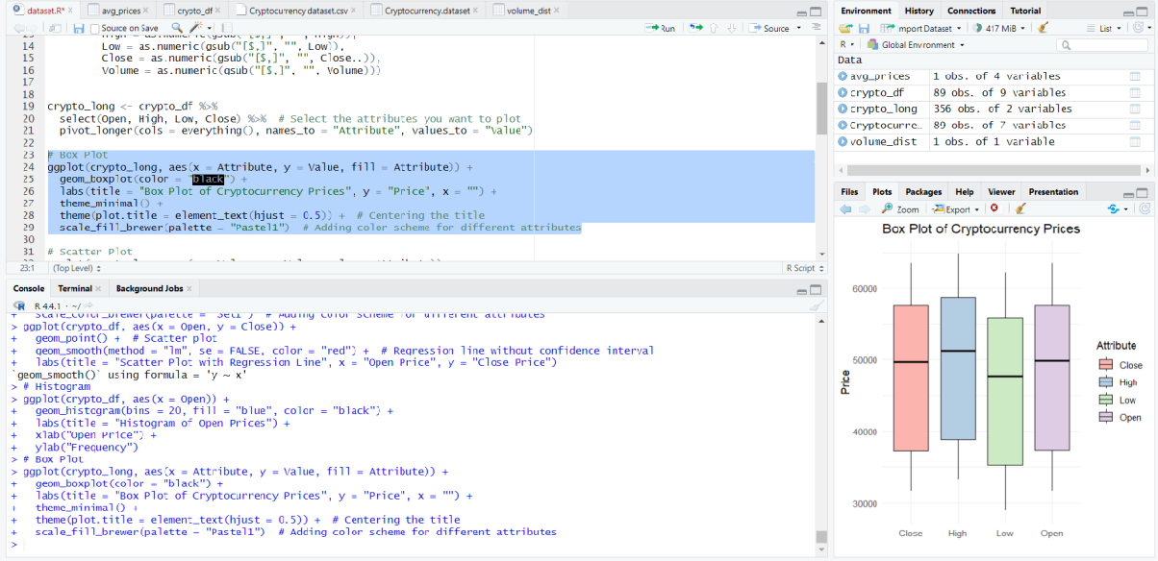

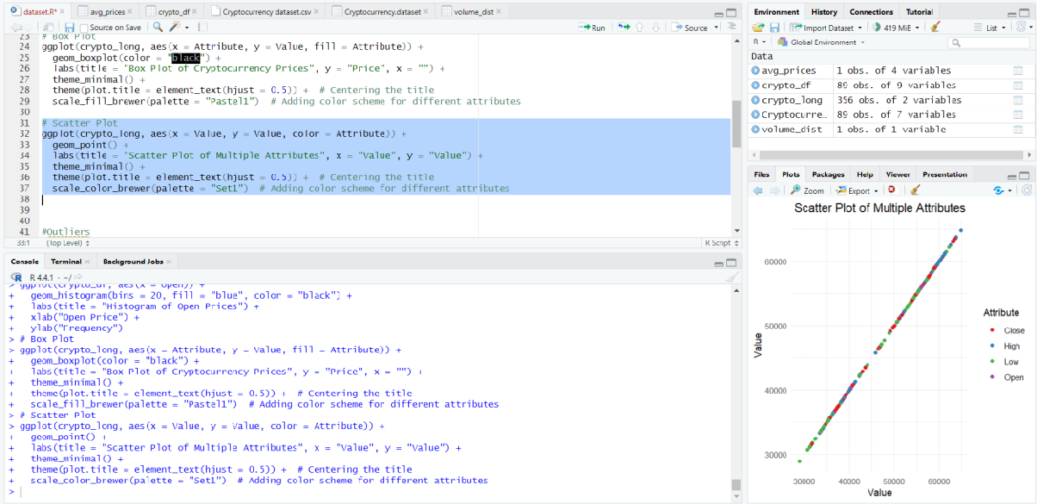

b.

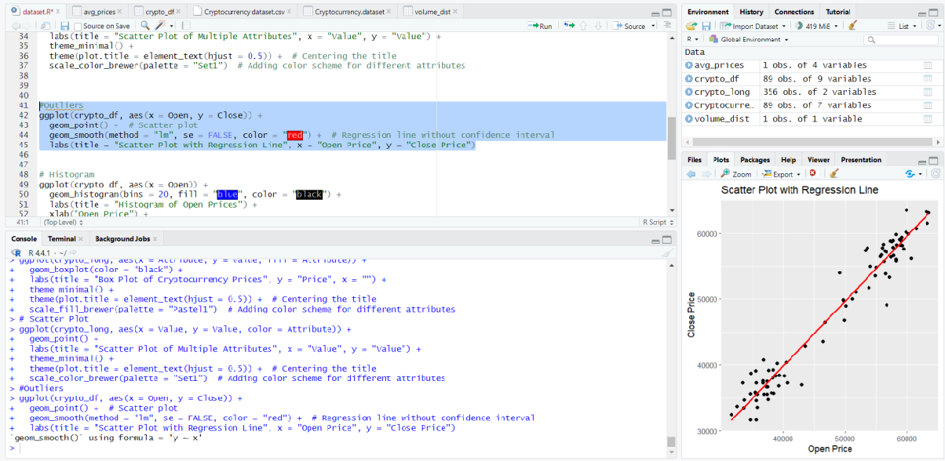

c.

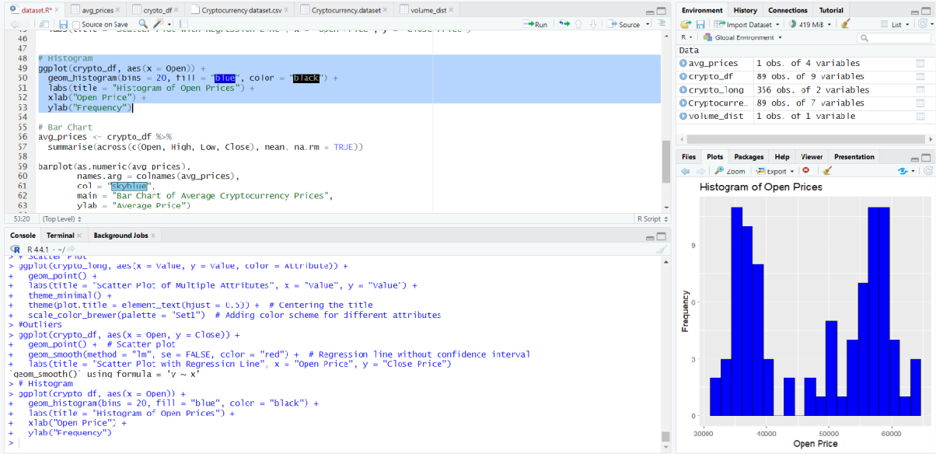

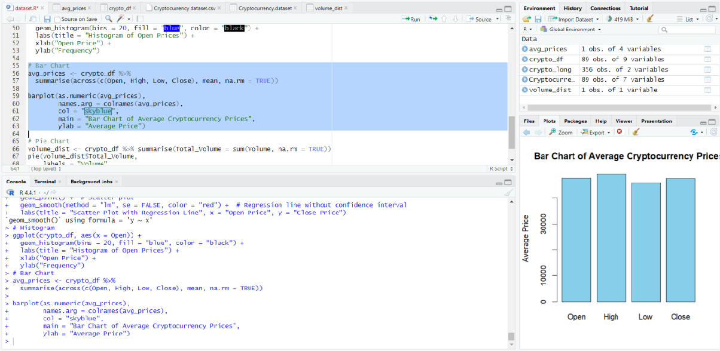

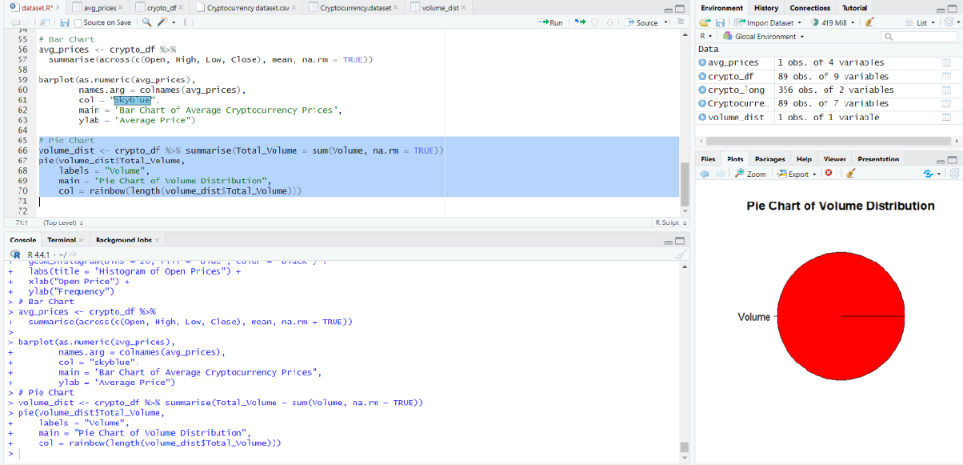

Dataset: Cricket a.

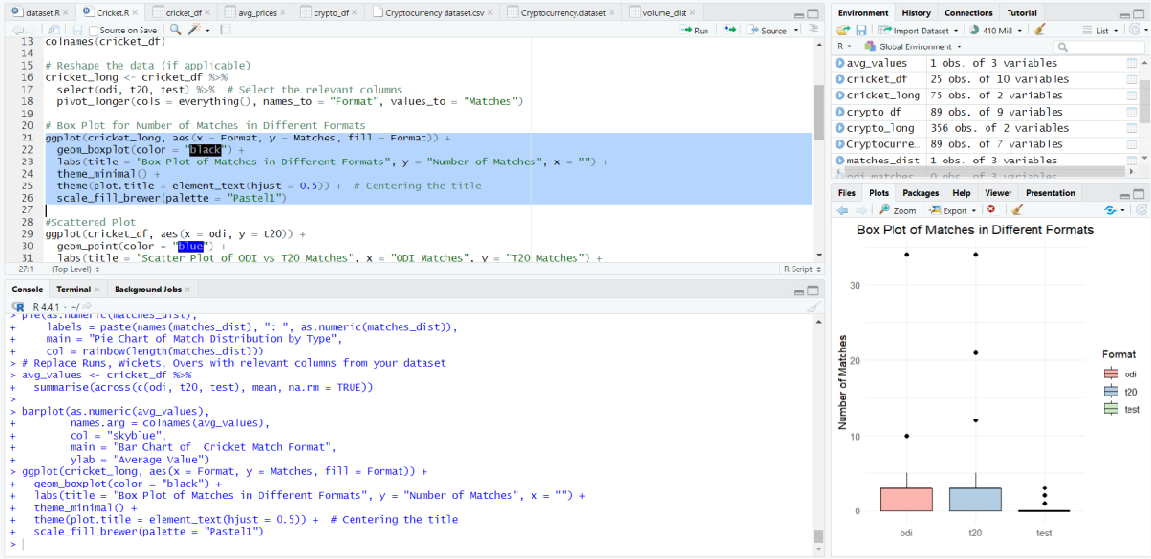

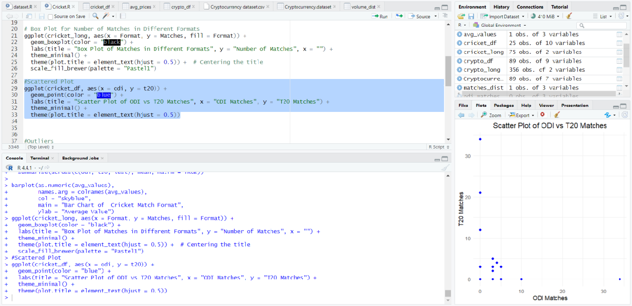

b.

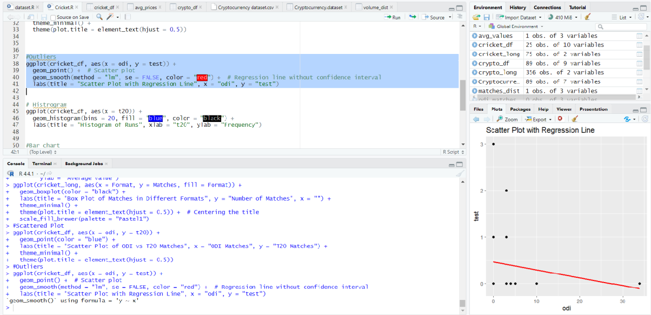

c.

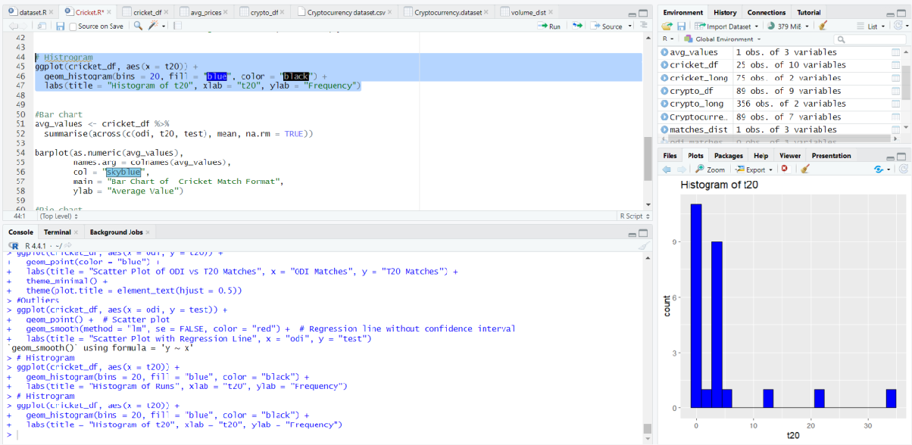

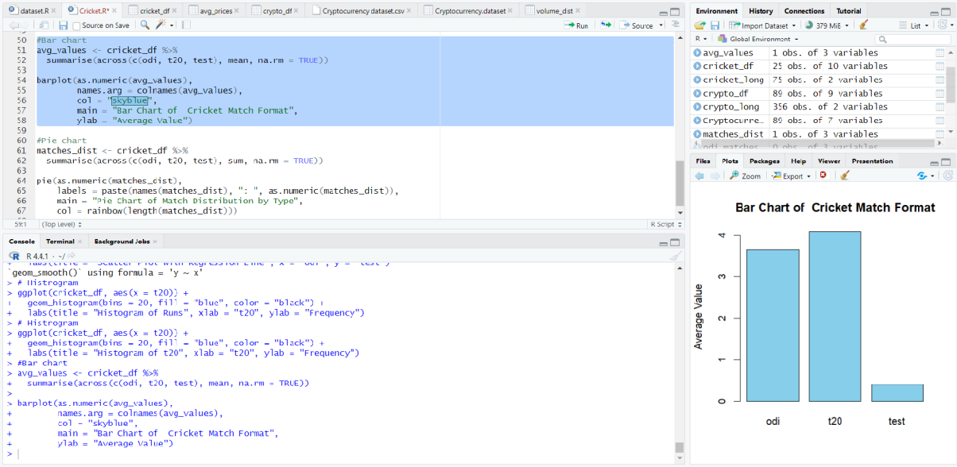

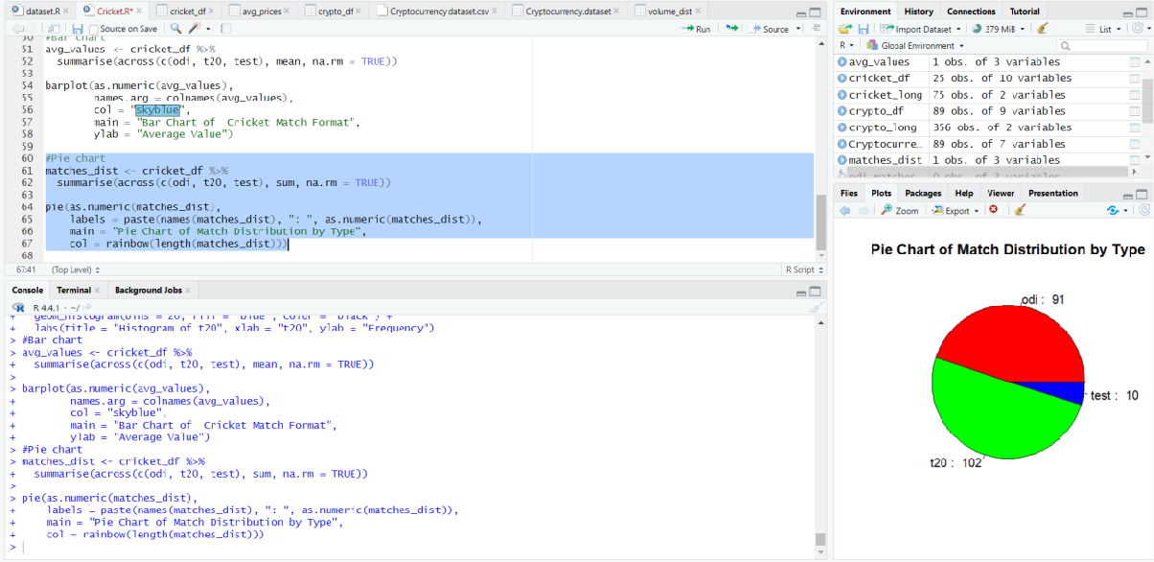

**Conclusion: -** In this program the concept of data Visualization and distributions using box and scatter plot as well as the outliers using plot like histogram, bar chart and pie chart.

## Assignment 5

**AIM: -** Create a model in R using R language where it includes sampling technique using sample.split, covariance, correlation, then finding deviation between dataset then plot linear regression for the dataset customer_churn.

**Objectives: -** To interpret the dataset using correlation, covariance by sampling data and understand the correlation using heat map graph. To understand the deviation between dataset **Algorithm:-** Creating a Model with Sampling and Linear Regression in R.

1. Load necessary libraries:
   * Install and load required libraries (e.g., caret, ggplot2).
2. Load the customer_churn dataset:
   * Read or load the customer_churn dataset into a suitable data structure.
3. Sampling technique using sample.split:
   * Use the sample.split() function from the caret package to split the dataset into training and testing sets.
4. Covariance and Correlation:
   * Calculate the covariance matrix and correlation matrix for the dataset.
   * Example: `cov_matrix <- cov(customer_churn)`

`cor_matrix <- cor(customer_churn)`

1. Find deviations between datasets:
   * Calculate deviations between variables or any other specific analysis as needed.
2. Linear Regression:
   * Fit a linear regression model using lm() on the training dataset.
   * Example: `model <- lm(Dependent_Variable ~ Independent_Variables, data = training_set)`
3. Predictions:
   * Use the predict() function to obtain predictions on the testing dataset.
   * Example: `predictions <- predict(model, newdata = testing_set)`
4. Plot Linear Regression:
   * Use ggplot2 to create a scatter plot with the linear regression line.
   * Example: ```R

ggplot(data = testing_set, aes(x = Independent_Variable, y = Dependent_Variable)) + geom_point() +

geom_smooth(method = "lm", se = FALSE, color = "blue") +

labs(title = "Linear Regression Plot", x = "Independent Variable", y = "Dependent Variable")

```

1. Display Results:
   * Print or visualize the results, including covariance, correlation matrices, deviations, and linear regression plot.
2. End of Algorithm

DataSet : Cricket

A :-CORRELATION AND COVARIANCE

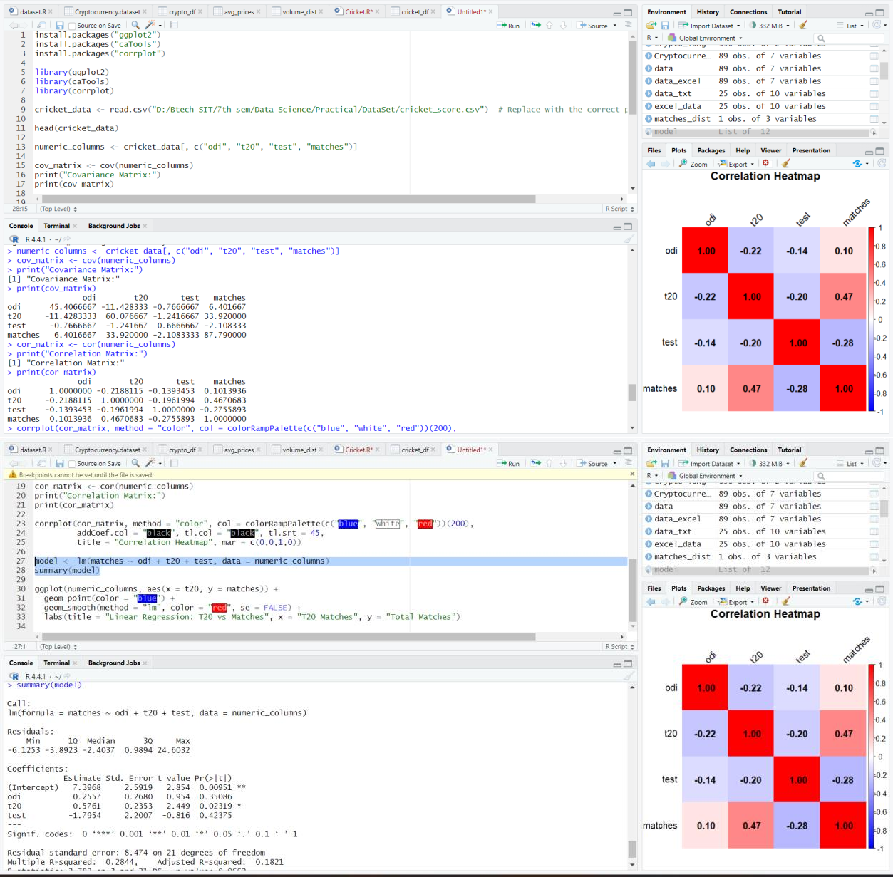

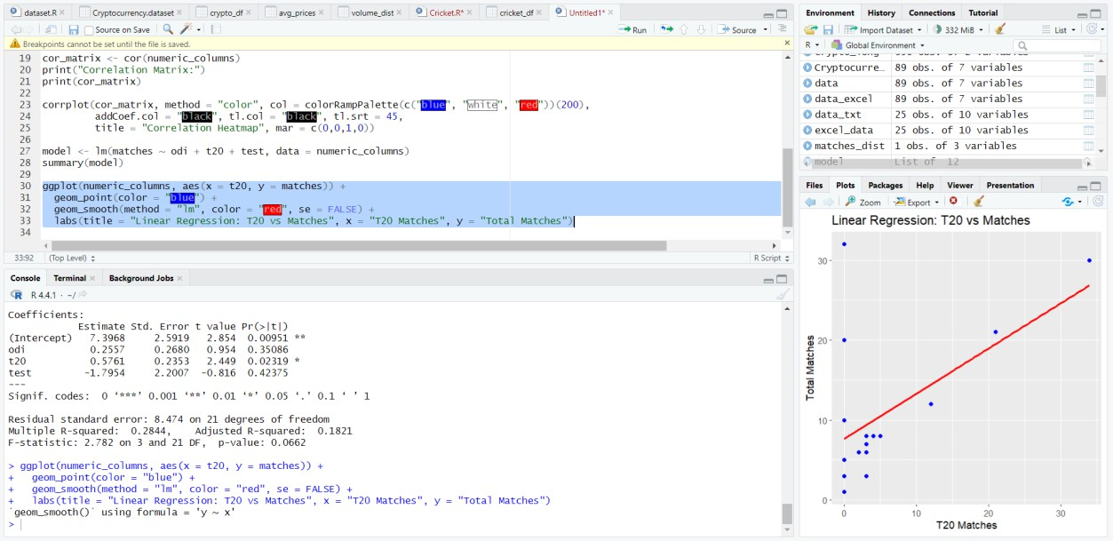B :- Finding deviation between dataset and plot linear regression for the dataset

DataSet:- myntra_products_catalog

A :- Correlation and Covariance

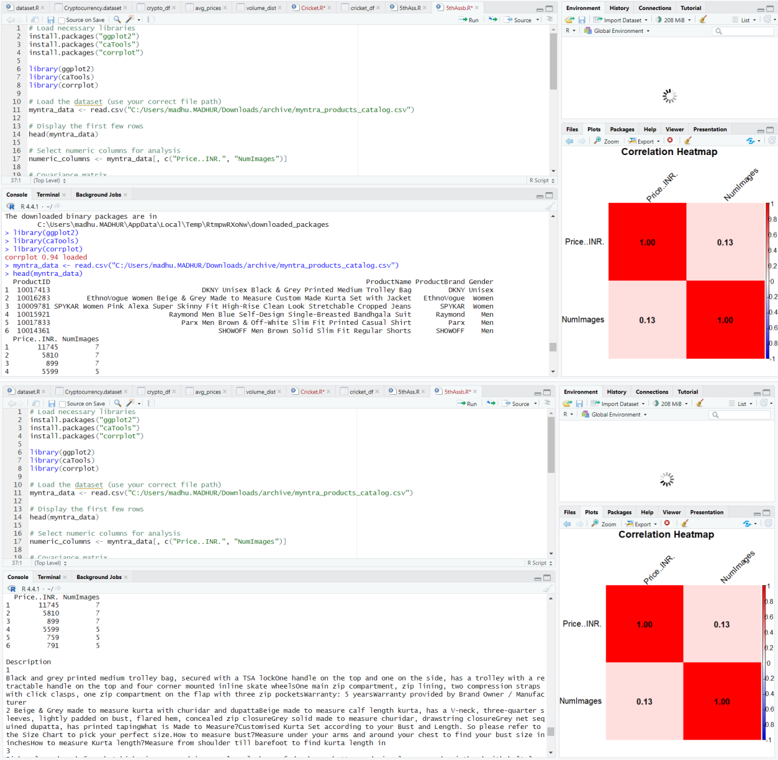

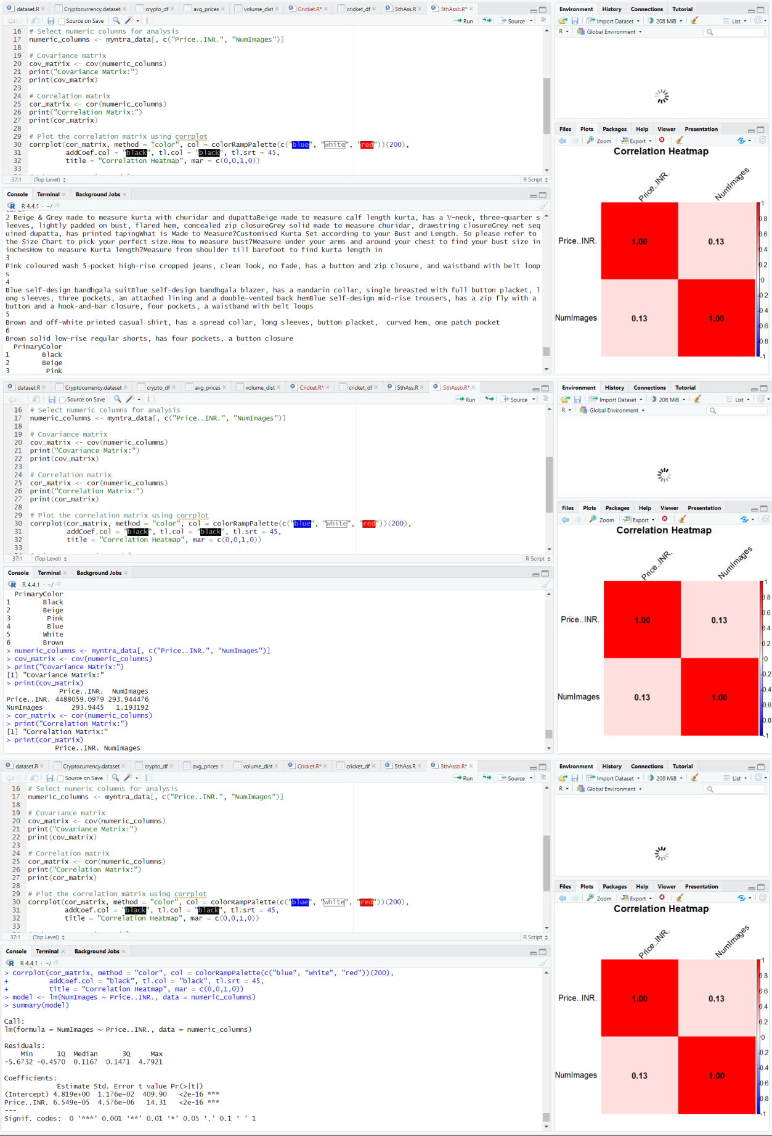

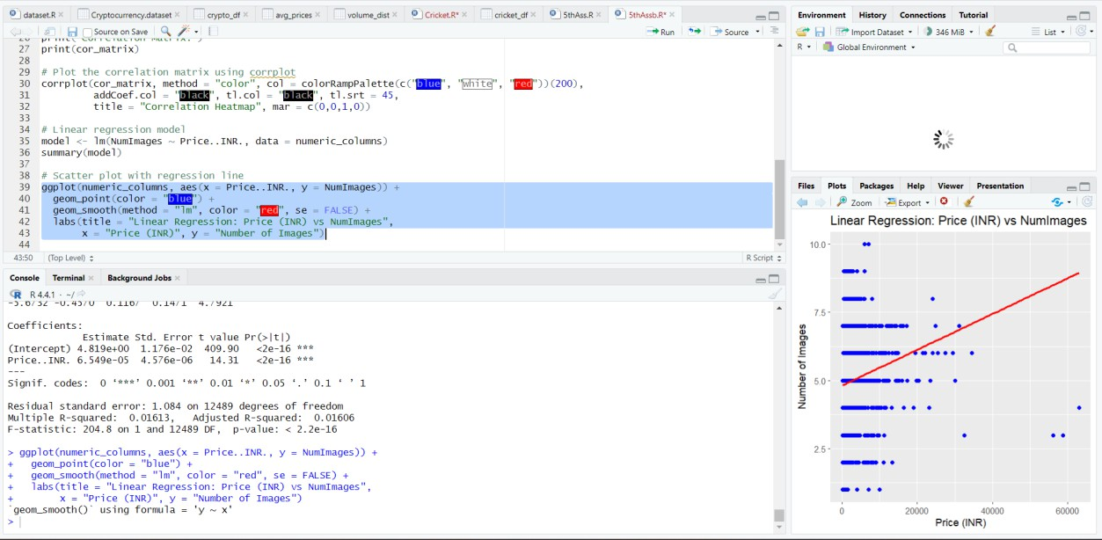B :- Finding deviation between dataset and plot linear regression for the dataset

Conclusion: In this assignment, we analyzed the correlation and covariance for the dataset, visualizing relationships with a correlation plot, and performed ANOVA to assess the impact of categorical variables. Additionally, we explored linear regression and deviation analysis for a customer churn dataset to understand predictive relationships between features and churn.

# Assignment 6

**AIM:** Import a data from web storage. Name the dataset and now do Logistic Regression to find out relation between variables that are affecting the admission of a student in a institute based on his or her GRE score, GPA obtained and rank of the student. Also check the model is fit or not require (foreign), require (MASS).

**Objectives: -** 1) To interpret the dataset using logistic regression and understand the correlation between variables. 2) To check model is under fitted or over fitted the dataset variables. 3) To check the model accuracy and error occurred.

#### Algorithm: Logistic Regression for Admission Prediction in R

1. Load necessary libraries:
   * Install and load required libraries (e.g., foreign, MASS).
2. Import data from web storage:
   * Use a web URL or any available online resource to load the dataset.
   * Example:

```R library(foreign)

url <- "https://example.com/your_data_file.csv" # Replace with your actual data URL dataset <- read.csv(url)

```

1. Name the dataset:
   * Assign meaningful column names to the dataset.
   * Example:

```R

col_names <- c("GRE_Score", "GPA", "Rank", "Admission") names(dataset) <- col_names

```

1. Data preprocessing:
   * Check for missing values and handle them if necessary.
   * Convert Rank to a factor variable if it represents categories (e.g., High, Medium, Low).
   * Example:

```R

# Handle missing values if needed # Convert Rank to a factor variable

dataset$Rank <- as.factor(dataset$Rank)

```

1. Split the dataset:
   * Use sample.split() or any other splitting technique to divide the dataset into training and testing sets.
   * Example:

```R library(caret)

set.seed(123) # Set seed for reproducibility

split_indices <- createDataPartition(dataset$Admission, p = 0.7, list = FALSE) training_set <- dataset[split_indices, ]

testing_set <- dataset[-split_indices, ]

```

1. Logistic Regression:
   * Fit a logistic regression model on the training set to predict Admission based on GRE_Score, GPA, and Rank.
   * Example:

```R library(MASS)

logistic_model <- glm(Admission ~ GRE_Score + GPA + Rank, data = training_set, family = "binomial")

```

1. Predictions:
   * Use predict() on the testing set to obtain predictions.
   * Example:

```R

predictions <- predict(logistic_model, newdata = testing_set, type = "response")

```

1. Model Evaluation:
   * Analyze model performance, ROC curves, or other relevant metrics.
   * Example:

```R

library(pROC) # For ROC analysis

roc_curve <- roc(testing_set$Admission, predictions) auc_value <- auc(roc_curve)

```

1. Check model fit:
   * Analyze model coefficients, p-values, and other diagnostic measures to check if the logistic regression model is a good fit.
   * Example:

```R summary(logistic_model)

```

1. Display Results:
   * Print or visualize the evaluation metrics, ROC curves, and model fit analysis.
2. End of Algorithm.

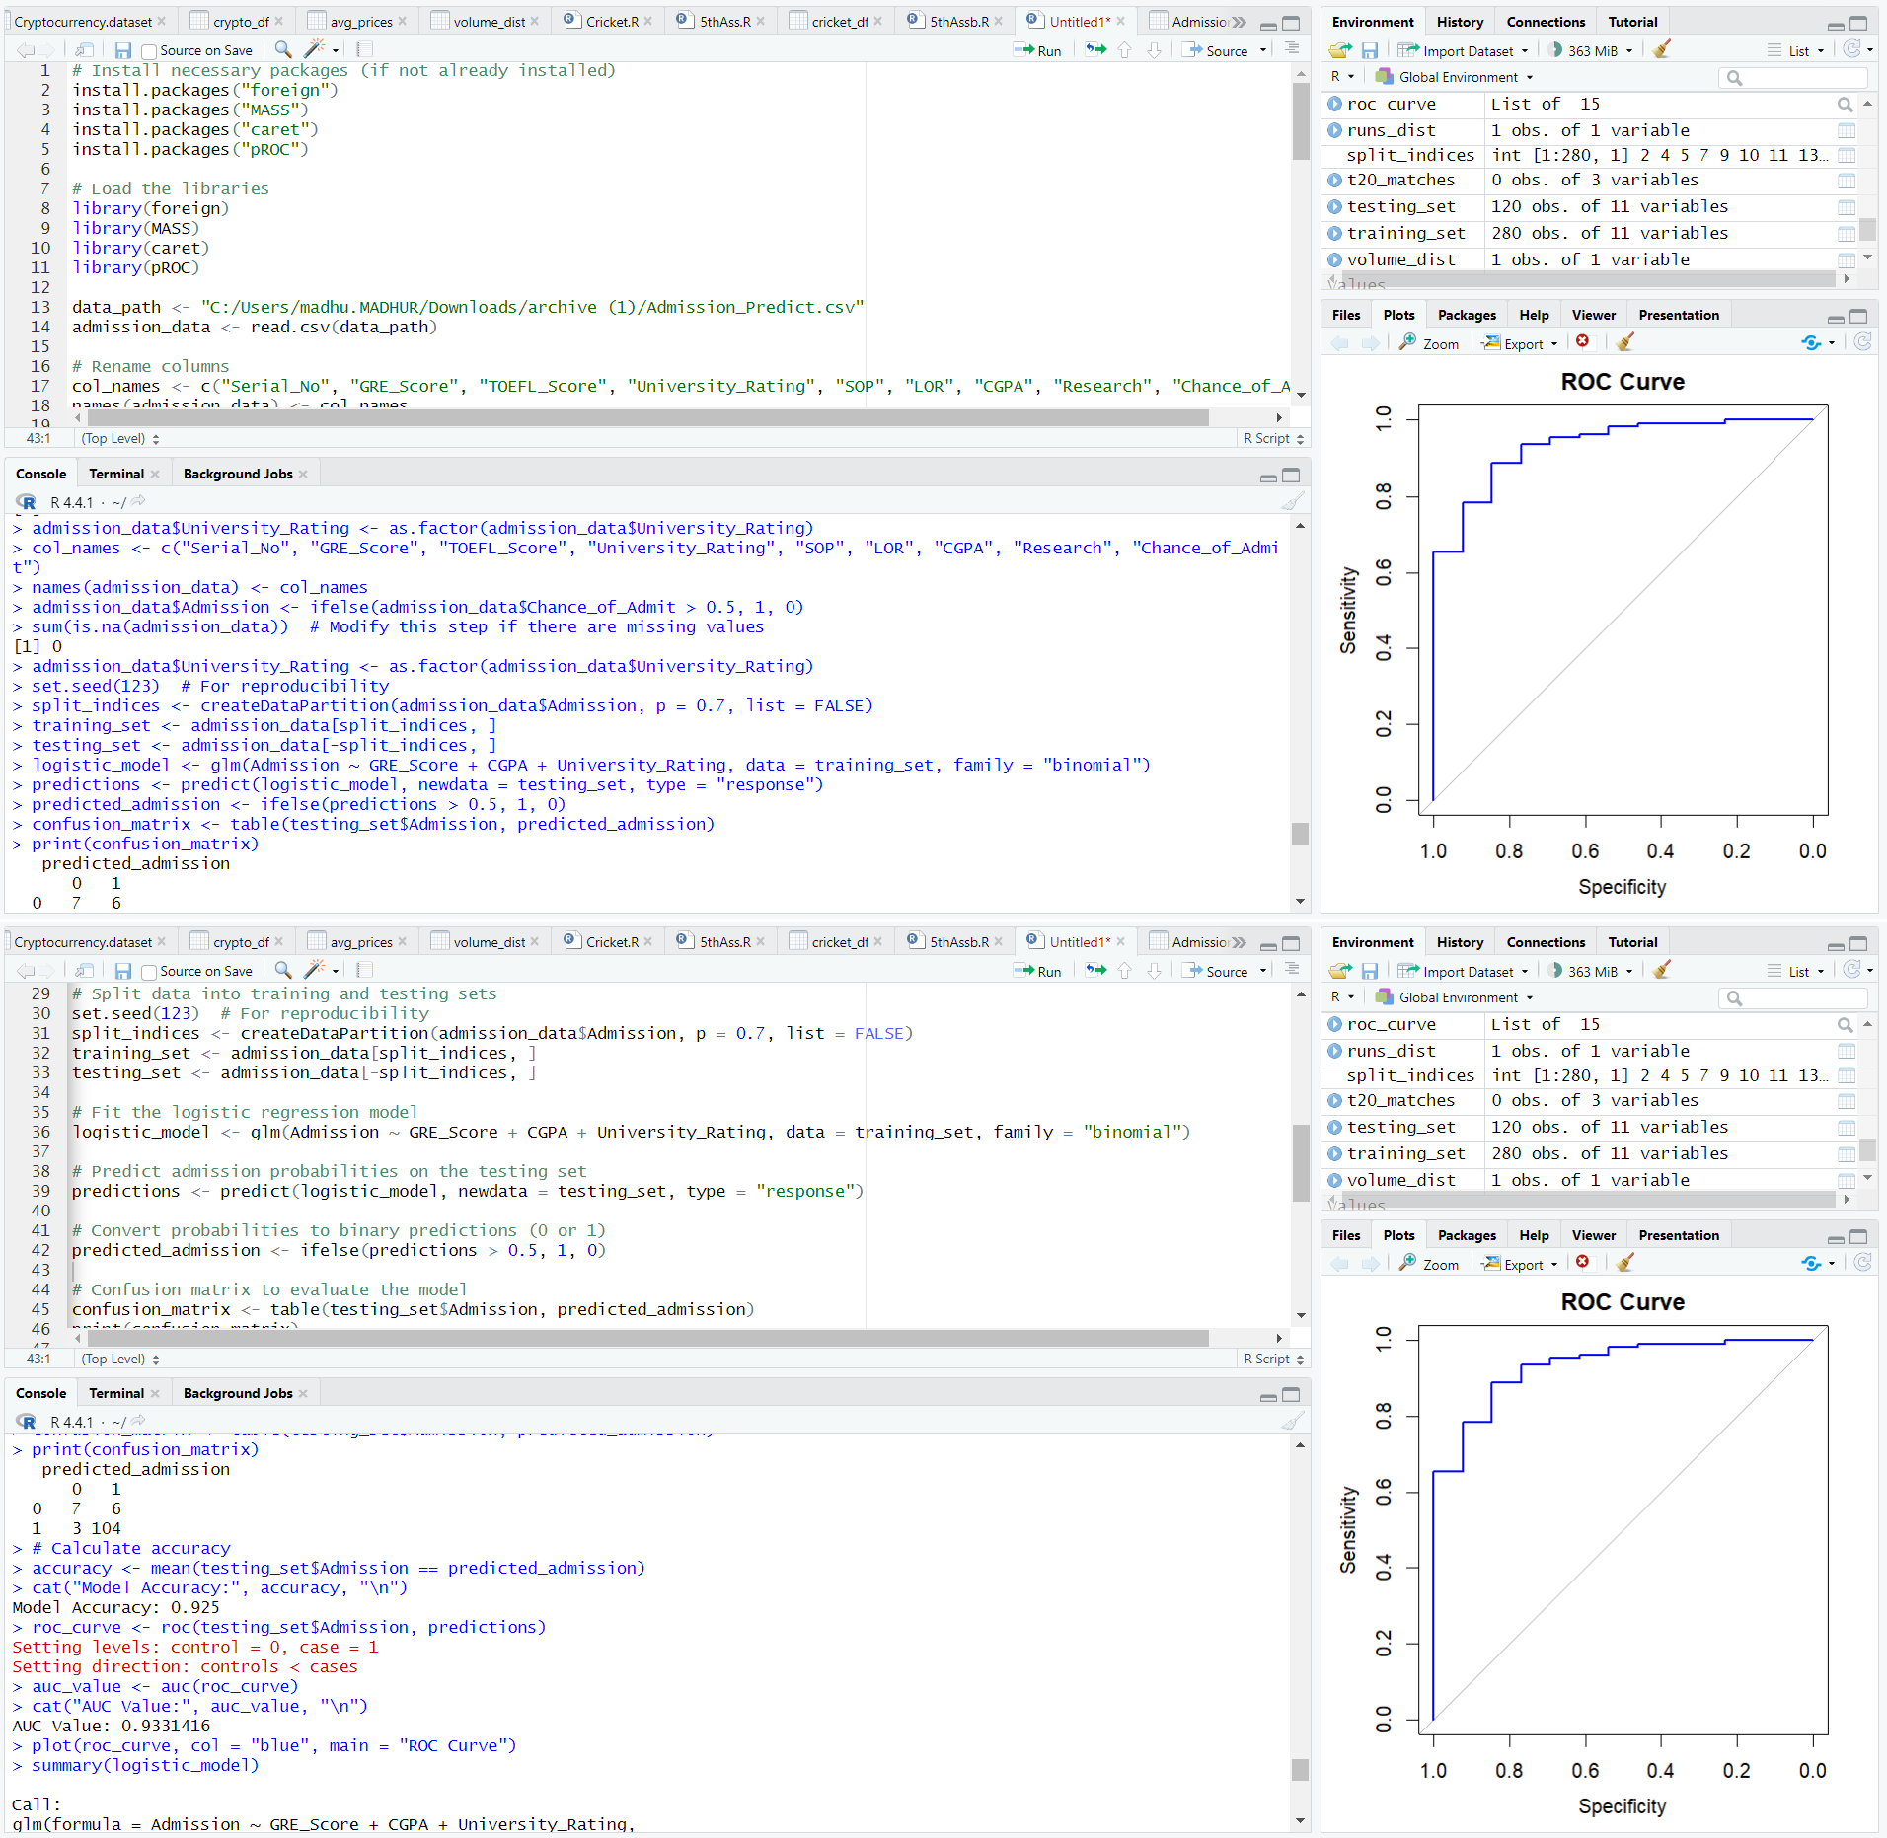

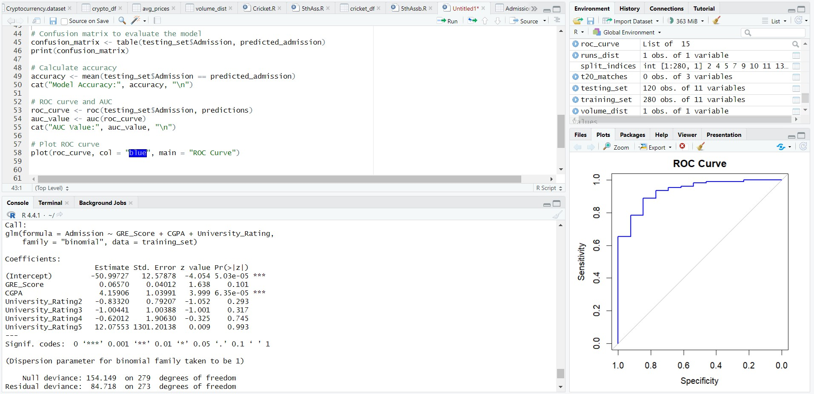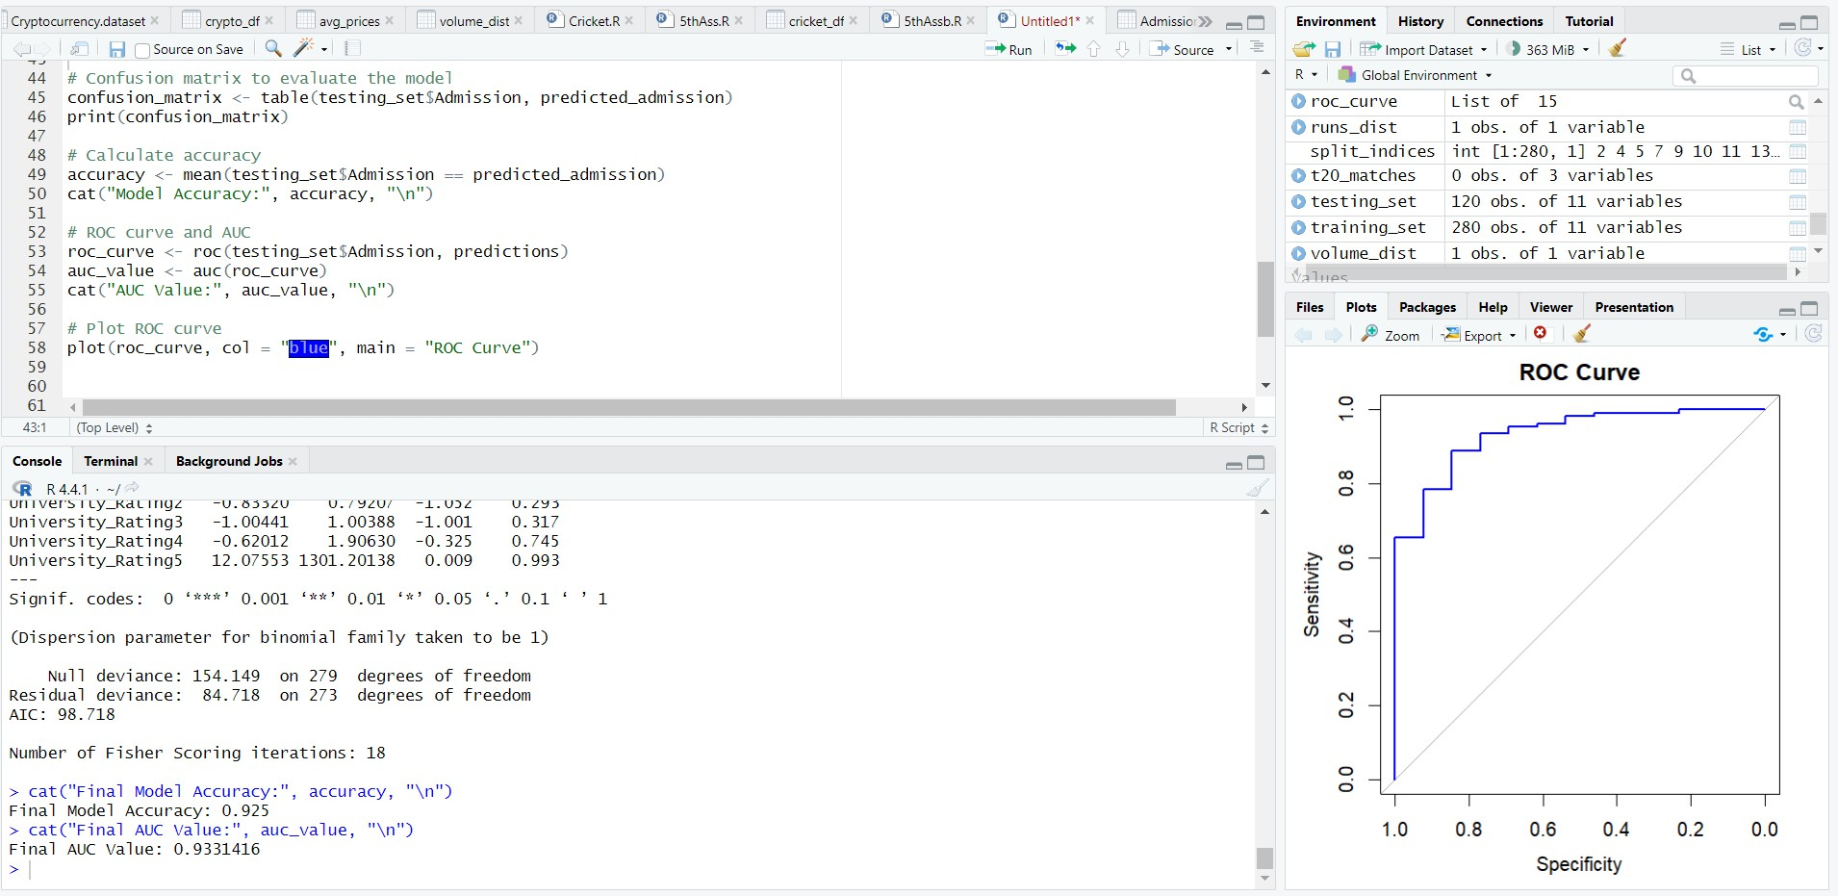

Conclusion:- logistic regression effectively identifies and quantifies the influence of GRE scores, GPA, and student rank on admission outcomes, while also assessing the model's fit, accuracy, and potential overfitting or underfitting.

# Assignment 7

**AIM:** Apply multiple regressions, if data have a continuous independent variable. Apply on above dataset.

**Objectives: -** 1) To interpret the dataset using multiple regression and understand the correlation between variables. 2) To check model is under fitted or over fitted the dataset variables. 3) To check the model accuracy and error occurred.

**Algorithm:** Multiple Linear Regression with Continuous Independent Variable Load necessary libraries:

Install and load required libraries (e.g., tidyverse for data manipulation and visualization, caret for modeling).

Import or load your dataset:

Read or load your dataset into a suitable data structure. Explore the dataset:

Examine the structure and summary statistics of the dataset. Handle missing values and outliers if necessary.

Identify dependent and independent variables:

Identify the dependent variable (response) and continuous independent variable(s) (predictors) in your dataset.

Split the dataset:

Use sample.split() or any other splitting technique to divide the dataset into training and testing sets.

Multiple Linear Regression:

Fit a multiple linear regression model on the training set. Example:

```R library(caret)

model <- lm(Dependent_Variable ~ Continuous_Independent_Variable1 + Continuous_Independent_Variable2 + ..., data = training_set)

``` Predictions:

Use predict() on the testing set to obtain predictions. Example:

```R

predictions <- predict(model, newdata = testing_set)

```

Model Evaluation:

Evaluate the performance of the multiple linear regression model.

Calculate metrics such as Mean Squared Error (MSE), R-squared, Adjusted R-

squared, etc. Example:

```R

mse <- mean((predictions - testing_set$Dependent_Variable)^2) r_squared <- cor(predictions, testing_set$Dependent_Variable)^2

```

Check model fit:

Analyze model coefficients, p-values, and diagnostic measures to assess the model fit.

Example:

```R summary(model)

```

Visualize the results:

Create visualizations such as scatter plots, residual plots, or other relevant plots to assess model performance.

Example:

```R plot(model)

```

Display Results:

Print or visualize the evaluation metrics, model coefficients, and diagnostic plots.

End of Algorithm

### Output

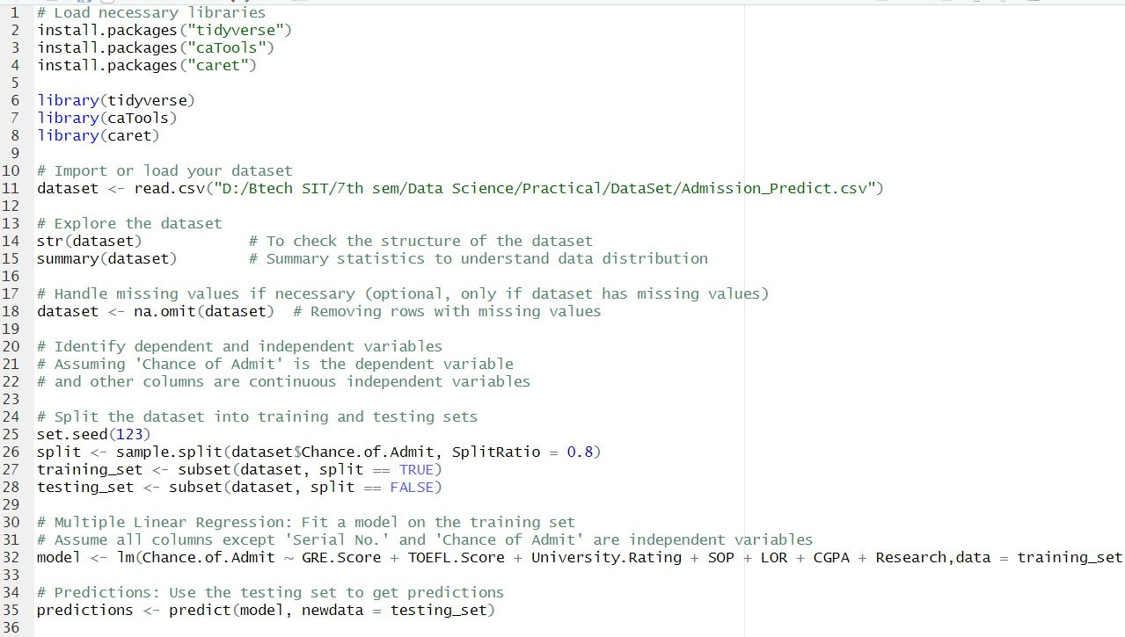

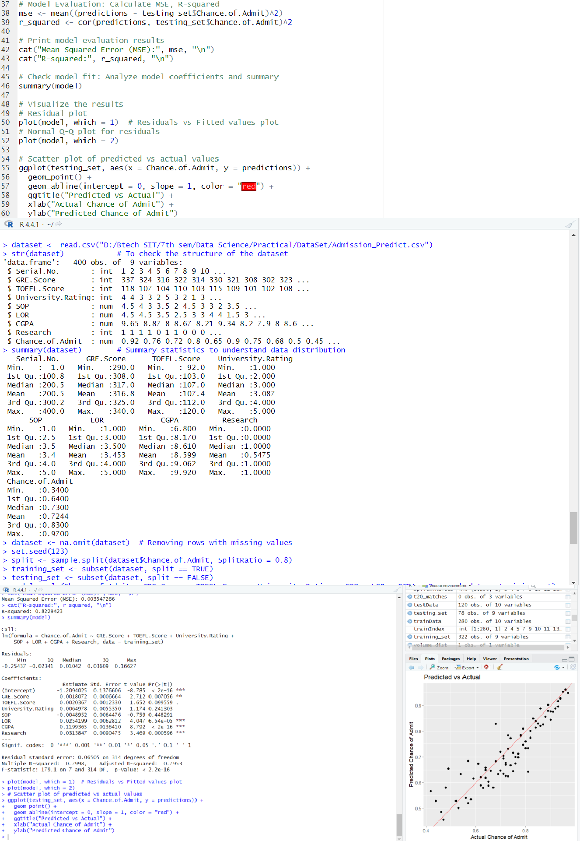

**Conclusion: -**

In the program we have implemented multiple regression. The program also explains about create visualizations such as scatter plots, residual plots, or other relevant plots to assess model performance.

# Assignment 8

**AIM:** Apply multiple regressions, if data have a continuous independent variable. Apply on above dataset. 1. Calculate Accuracy. 2. Mean, Mode, Median, 3.Interquartile range, 4.Accuracy, Precision, Recall, 5.Entropy, Information gain.

**Objectives: -** 1) To interpret the dataset using multiple regression and understand the correlation between variables. 2) To check model is under fitted or over fitted the dataset variables. 3) To check the model accuracy and error occurred. 4) To understand the purpose of information gain, entropy, recall and precision.

**Algorithm:** Multiple Linear Regression and Statistical Metrics Calculation in R.

1. Load necessary libraries:
   * Install and load required libraries (e.g., caret for modeling, e1071 for entropy calculations).

```R

install.packages(c("caret", "e1071")) library(caret)

library(e1071)

```

1. Import or load your dataset:
   * Read or load your dataset into a suitable data structure.

```R

# Assuming 'your_data.csv' is the name of your dataset file dataset <- read.csv("your_data.csv")

```

1. Explore the dataset:
   * Examine the structure and summary statistics of the dataset.
   * Handle missing values and outliers if necessary.
2. Identify dependent and independent variables:
   * Identify the dependent variable (response) and continuous independent variable(s) (predictors) in your dataset.
3. Split the dataset:
   * Use sample.split() or any other splitting technique to divide the dataset into training and testing sets.

```R

set.seed(123) # Set seed for reproducibility

split_indices <- createDataPartition(dataset$Dependent_Variable, p = 0.7, list = FALSE) training_set <- dataset[split_indices, ]

testing_set <- dataset[-split_indices, ]

```

1. Multiple Linear Regression:
   * Fit a multiple linear regression model on the training set.

```R

model <- lm(Dependent_Variable ~ Continuous_Independent_Variable1 + Continuous_Independent_Variable2 + ..., data = training_set)

```

1. Predictions:
   * Use predict() on the testing set to obtain predictions.

```R

predictions <- predict(model, newdata = testing_set)

```

1. Model Evaluation:
   * Evaluate the performance of the multiple linear regression model.
   * Calculate metrics such as Mean Squared Error (MSE), R-squared, Adjusted R-squared, etc.

```R

mse <- mean((predictions - testing_set$Dependent_Variable)^2) r_squared <- cor(predictions, testing_set$Dependent_Variable)^2

```

1. Statistical Metrics Calculation:
2. Accuracy:

```R

accuracy <- mean(predictions == testing_set$Dependent_Variable)

```

1. Mean, Mode, Median, Interquartile Range:

```R

mean_value <- mean(testing_set$Dependent_Variable)

mode_value <- as.numeric(names(sort(table(testing_set$Dependent_Variable), decreasing = TRUE)[1]))

median_value <- median(testing_set$Dependent_Variable) iqr_value <- IQR(testing_set$Dependent_Variable)

```

1. Precision, Recall:

```R

true_positive <- sum(predictions == 1 & testing_set$Dependent_Variable == 1) false_positive <- sum(predictions == 1 & testing_set$Dependent_Variable == 0) false_negative <- sum(predictions == 0 & testing_set$Dependent_Variable == 1)

precision <- true_positive / (true_positive + false_positive) recall <- true_positive / (true_positive + false_negative)

```

1. Entropy, Information Gain (if applicable):

```R

entropy_before <- entropy(testing_set$Dependent_Variable) entropy_after <- entropy(predictions)

information_gain <- entropy_before - entropy_after

```

1. Display Results:
   * Print or visualize the evaluation metrics, statistical metrics, and model coefficients.
2. End of Algorithm.

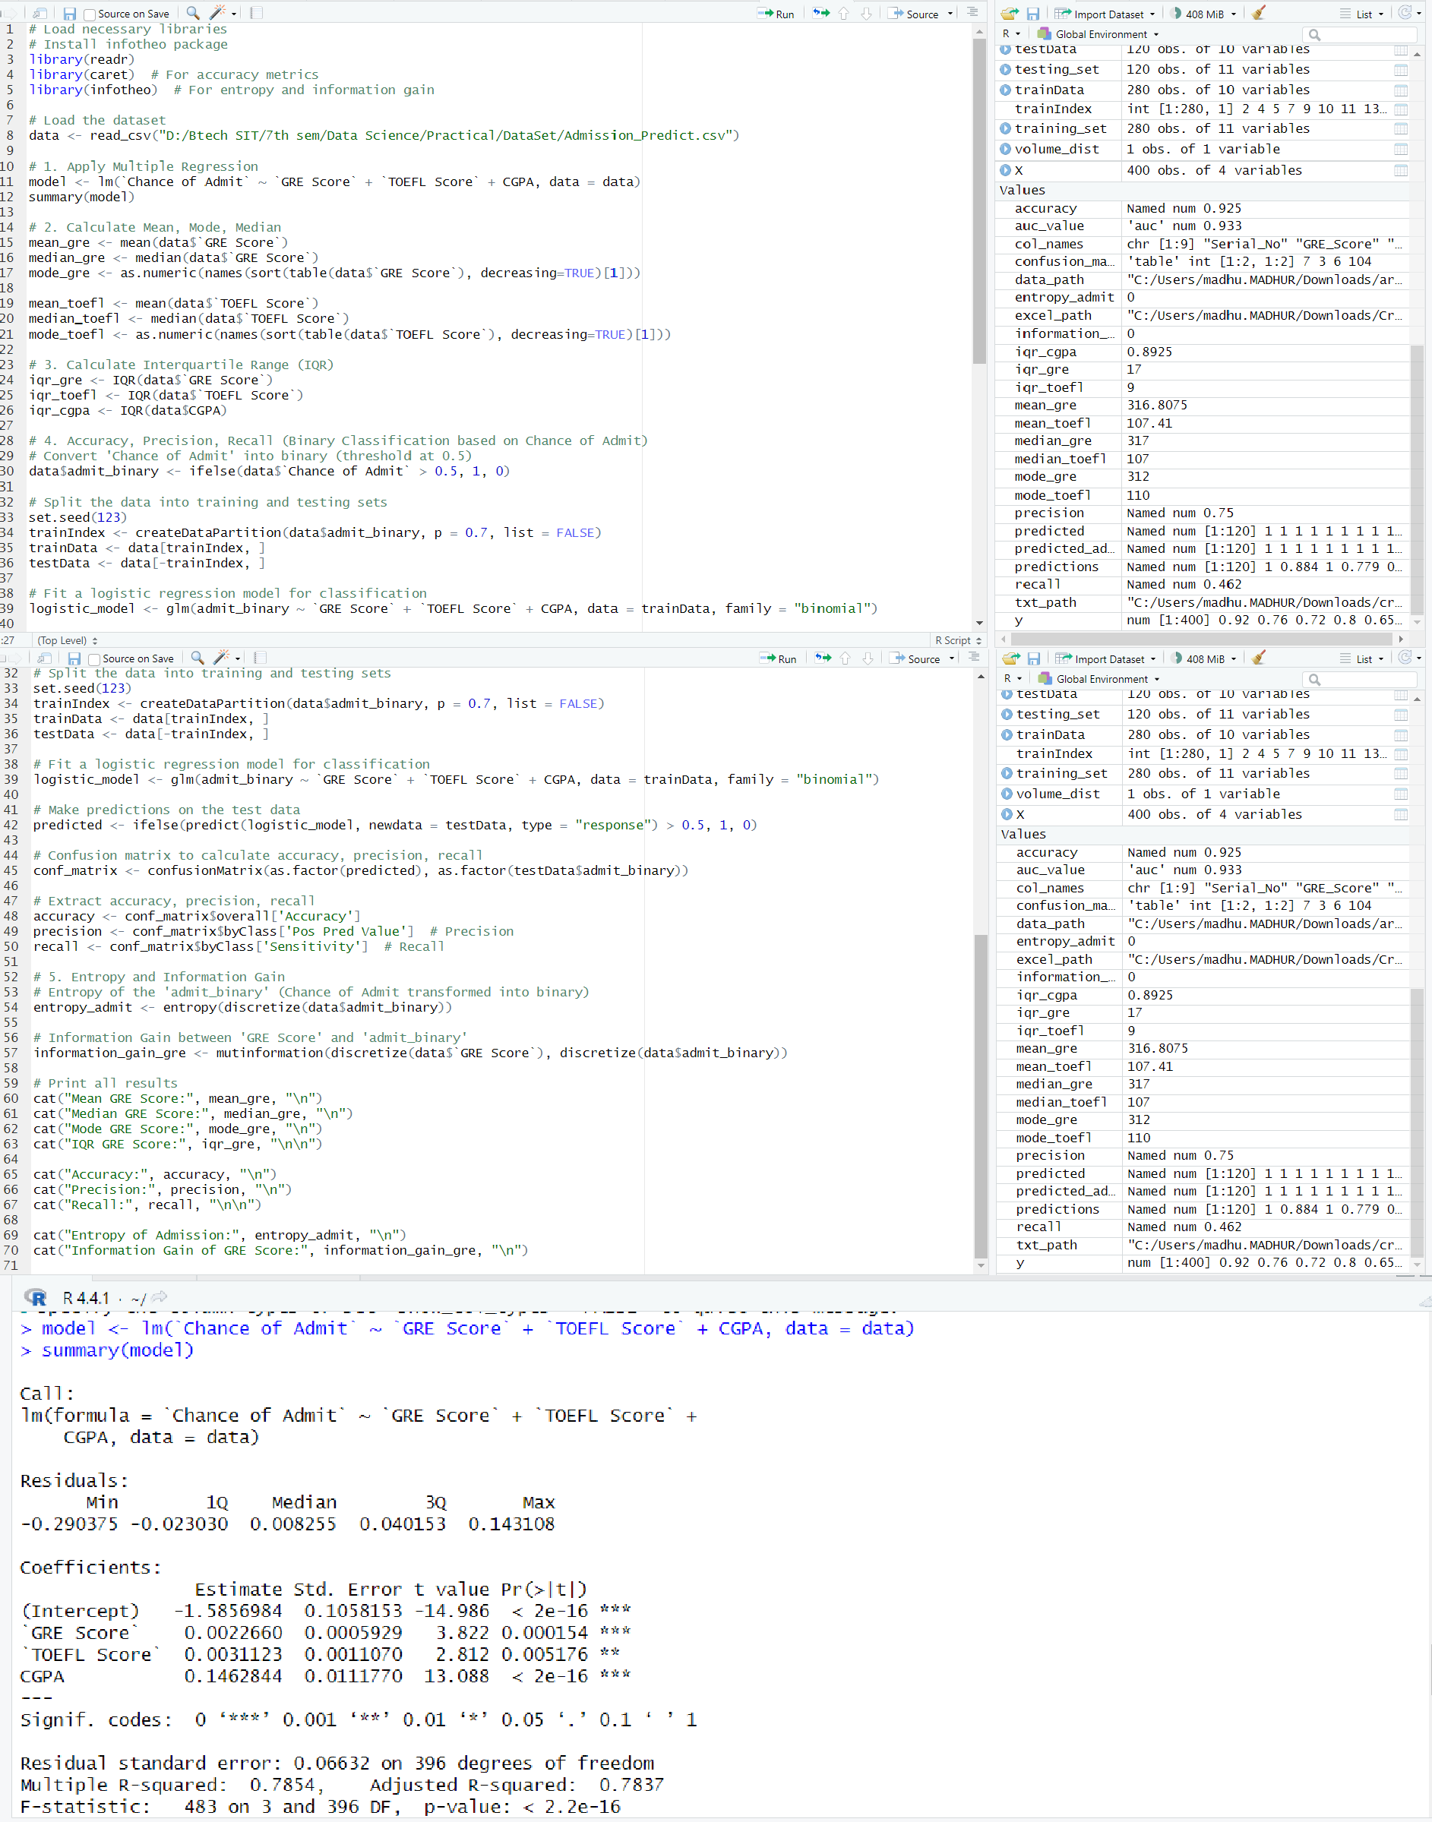

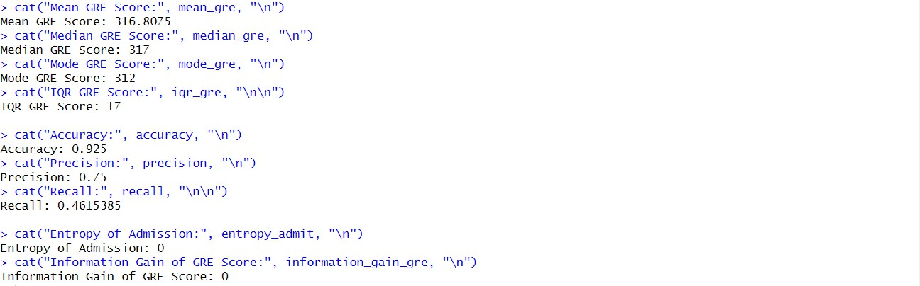

#### Conclusion: -

In the program, we have implemented multiple regression to interpret the dataset using multiple regression and understand the correlation between variables. It also explain model is under fitted or over fitted the dataset variables and the purpose of information gain, entropy, recall and precision.

**Assignment 9**

**Aim:- CLASSIFICATION MODEL**

1. Student can use mtcars, iris, volcano, 50_startup.csv.
2. Student has to do classification of data and EDA.
3. Students are supposed to do classification using Random forest, Decision Tree, and Logistic regression.
4. Calculate, mean, mode, median, confusion matrix, recall, precision, entropy, R2 Score, Mean Square error, Mean Absolute Error Code.
5. Student can use mtcars, iris, volcano, 50_startup.csv.
6. Student has to do classification of data and EDA.
7. Students are supposed to do classification using Random forest, Decision Tree, and Logistic regression.
8. Calculate, mean, mode, median, confusion matrix, recall, precision, entropy, R2 Score, Mean Square error, Mean Absolute Error Code.

Dataset: cricket_score.csv

**Algorithm:** Classification and EDA with Metrics Calculation in R

1. Load necessary libraries:

- Install and load required libraries (randomForest, rpart, nnet, caret, e1071). install.packages(c("randomForest", "rpart", "nnet", "caret", "e1071")) library(randomForest)

library(rpart) library(nnet) library(caret) library(e1071)

1. Load datasets:

Let the student choose one of the datasets (mtcars, iris, volcano, 50_startup.csv) into a suitable data structure

1. Explore the dataset (EDA):

Examine the structure and summary statistics of the dataset.

Handle missing values, outliers, and perform any necessary data cleaning.

1. Split the dataset:

Use createDataPartition() or any other splitting technique to divide the dataset into training and testing sets.

1. Classification using Random Forest:
   1. Step-1: Select random K data points from the training set.
   2. Step-2: Build the decision trees associated with the selected data points (Subsets).
   3. Step-3: Choose the number N for decision trees that you want to build.
   4. Step-4: Repeat Step 1 & 2.
   5. Step-5: For new data points, find the predictions of each decision tree, and assign the new data points to the category that wins the majority votes.
2. Classification using Decision Tree:
   1. Step-1: Begin the tree with the root node, says S, which contains the complete dataset.
   2. Step-2: Find the best attribute in the dataset using Attribute Selection Measure (ASM).
   3. Step-3: Divide the S into subsets that contains possible values for the best attributes.
   4. Step-4: Generate the decision tree node, which contains the best attribute.
   5. Step-5: Recursively make new decision trees using the subsets of the dataset created in step 6.3. 6.6 Step-6: Continue this process until a stage is reached where you cannot further classify the nodes and called the final node as a leaf node.
3. Calculate Metrics of classification.

#### OUTPUT:

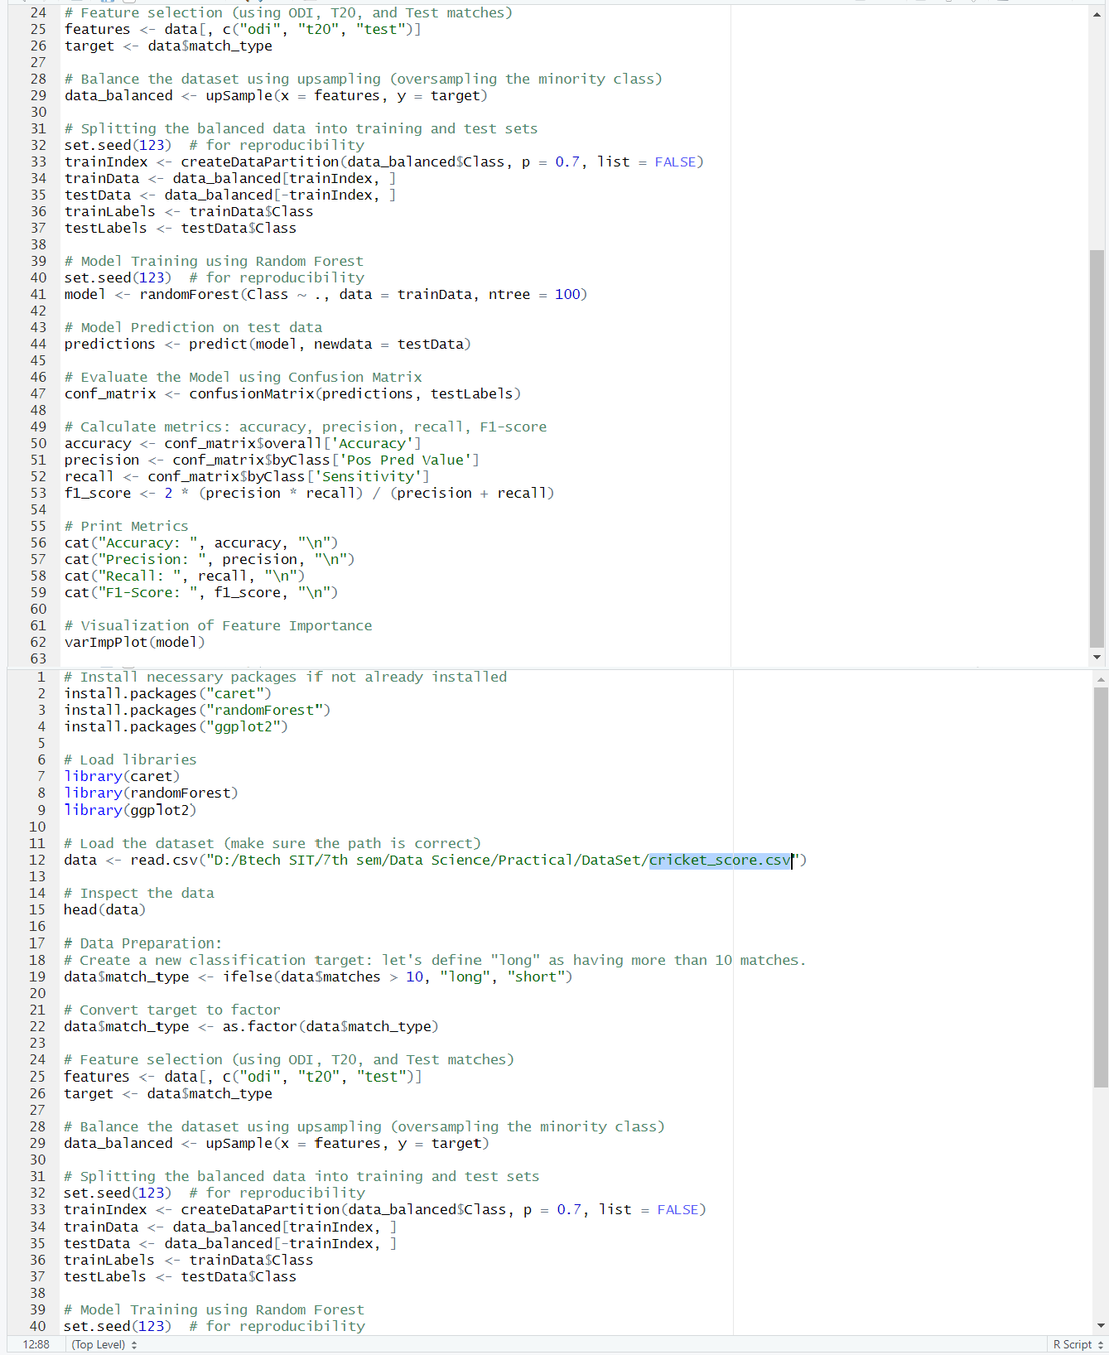

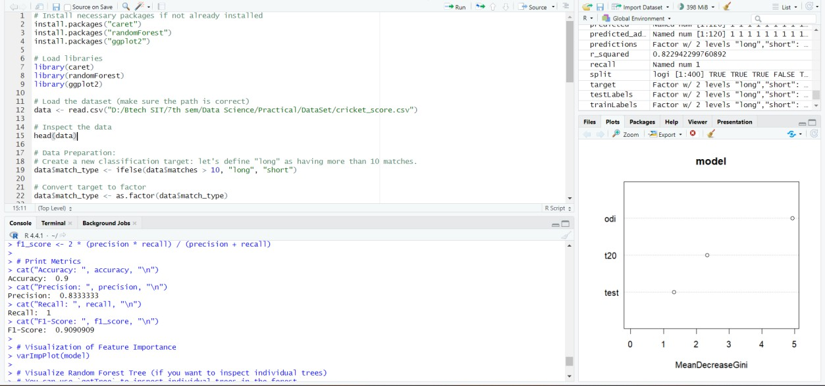

Conclusion:- In the program, we have implemented classification using decision tree, random forest. To interpret the dataset, the correlation between variables is explained. It also explain entropy, information gain, recall, precision of the model built for the data. It can also explain how to calculate error.

Name: Madhur Mahajan CSC3 PRN:22070122508

**Assignment 10**

**CLUSTERING MODEL**

**Aim:-** Use mtcars, iris, customer churn dataset for implementation, implement K-Mean clustering, Hierarchal clustering, Decision Tree, Random Forest using bagging Techniques. Calculate the MAE, MSE, Entropy, Precision, Recall, Accuracy, F1-score, ROC curve. Submit it along with output.

**Objective:** To understand the working principle of clustering.

**Algorithm:** Clustering and Classification with Metrics Calculation in R

1. Load necessary libraries:

- Install and load required libraries (kmeans, dendextend, rpart, randomForest, caret, pROC).

```R

install.packages(c("kmeans", "dendextend", "rpart", "randomForest", "caret", "pROC")) library(kmeans)

library(dendextend) library(rpart) library(randomForest) library(caret) library(pROC)

1. Load datasets:

Choose one of the datasets (mtcars, iris, customer churn) into a suitable data structure.

1. Data Preprocessing:

Handle missing values, outliers, and perform any necessary data cleaning

#### Implement K-Means clustering:

The working of the K-Means algorithm is explained in the below steps:

* 1. Step-1: Select the number K to decide the number of clusters.
  2. Step-2: Select random K points or centroids. (It can be other from the input dataset).
  3. Step-3: Assign each data point to their closest centroid, which will form the predefined K clusters.
  4. Step-4: Calculate the variance and place a new centroid of each cluster.
  5. Step-5**:** Repeat the third steps, which means reassign each datapoint to the new closest centroid of each cluster.
  6. Step-6: If any reassignment occurs, then go to step-4 else go to FINISH.
  7. Step-7: The model is ready.

#### Implement Hierarchical clustering:

The working of the Hierarchical clustering algorithm is explained in the below steps:

* 1. Step-1: Create each data point as a single cluster. Let's say there are N data points, so the number of clusters will also be N.
  2. Step-2: Take two closest data points or clusters and merge them to form one cluster. So, there will now be N-1 clusters.
  3. Step-3: Again, take the two closest clusters and merge them together to form one cluster. There will be N-2 clusters.
  4. Step-4: Repeat Step 3 until only one cluster left. So, we will get the following clusters.
  5. Step-5: Once all the clusters are combined into one big cluster, develop the dendrogram to divide the clusters as per the problem.

#### Implement Decision Tree:

* 1. Step-1: Begin the tree with the root node, says S, which contains the complete dataset.
  2. Step-2: Find the best attribute in the dataset using Attribute Selection Measure (ASM).
  3. Step-3: Divide the S into subsets that contains possible values for the best attributes.
  4. Step-4: Generate the decision tree node, which contains the best attribute.
  5. Step-5: Recursively make new decision trees using the subsets of the dataset created in step 6.3.
  6. Step-6: Continue this process until a stage is reached where you cannot further classify the nodes and called the final node as a leaf node.

#### Implement Random Forest with bagging:

* 1. Step 1: Multiple subsets are created from the original data set with equal tuples, selecting observations with replacement.
  2. Step 2: A base model is created on each of these subsets.
  3. Step 3: Each model is learned in parallel with each training set and independent of each other.

7.5 Step 4: The final predictions are determined by combining the predictions from all the models.

1. Calculate Metrics of clustering.

#### Output:-

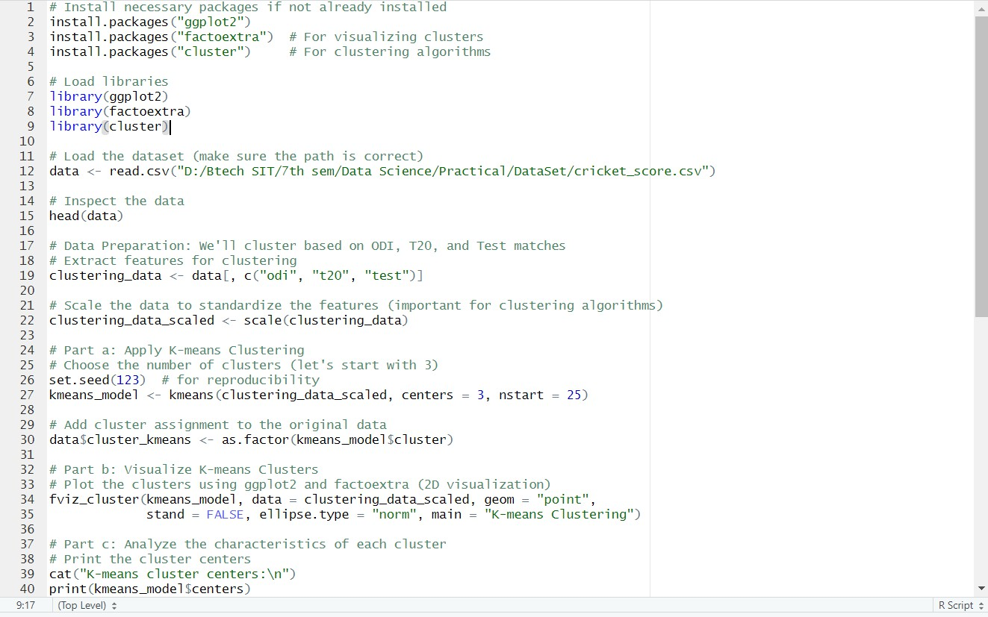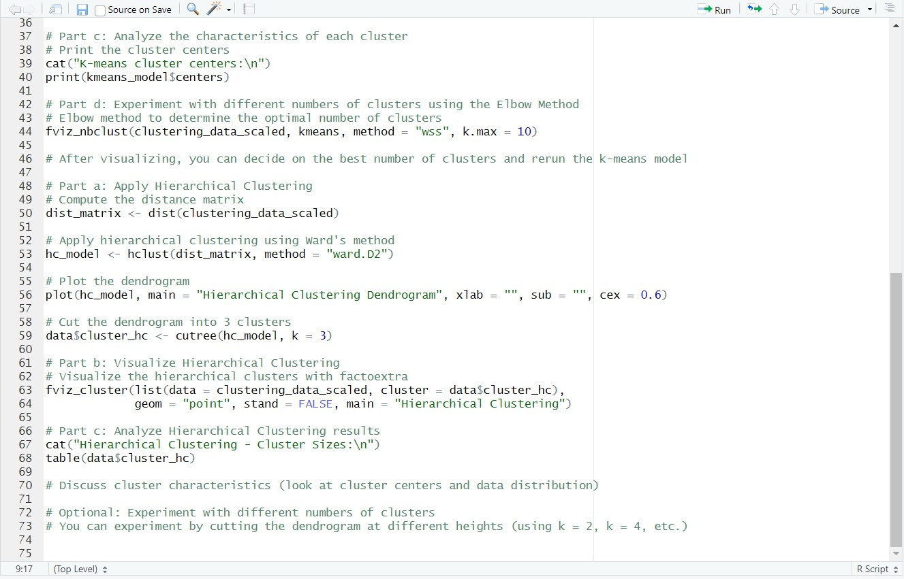

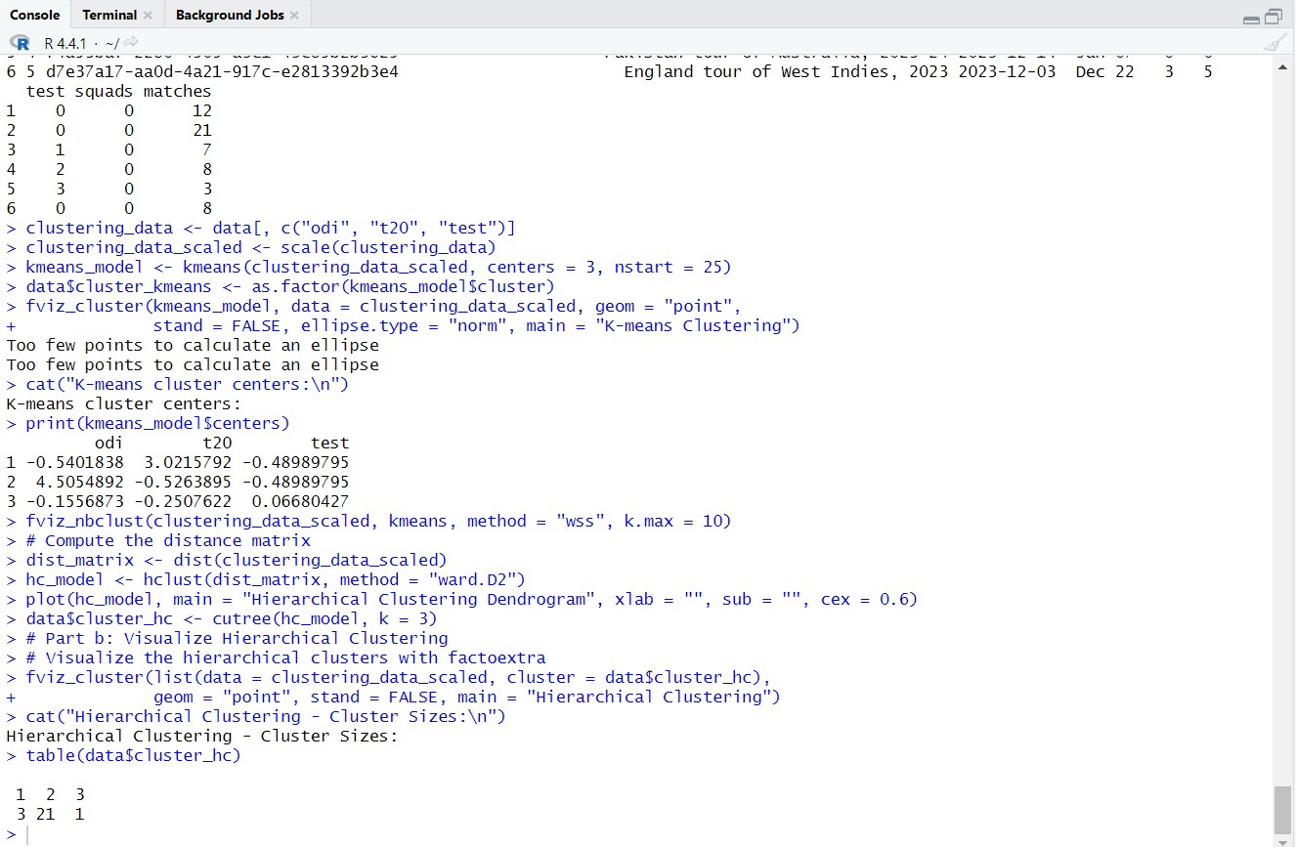

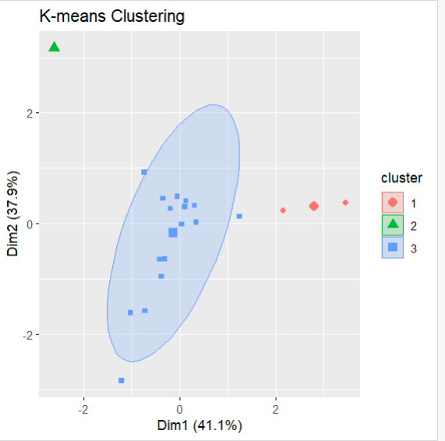

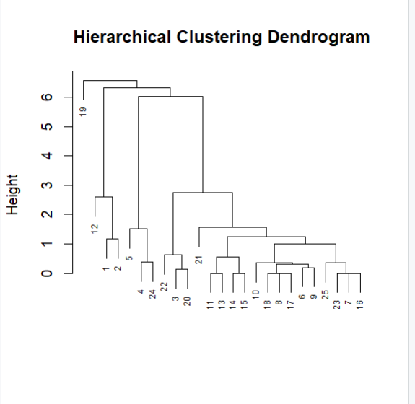

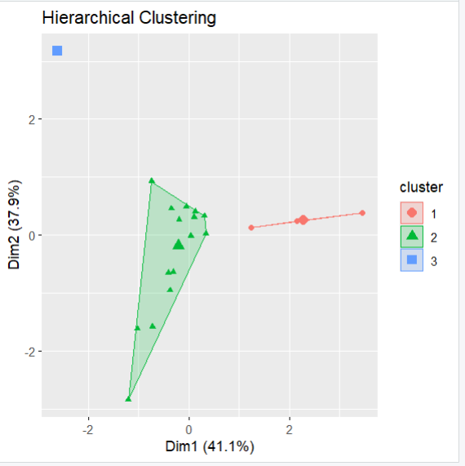

#### Conclusion: -

In the program, we have implemented clustering techniques using K-means algorithm, Hierarchal clustering algorithm. It also explains Decision Tree, and random forest clustering techniques along with metrics like precision, recall, accuracy and F1-score for the model built for the given data. It can also explain how to calculate error.